  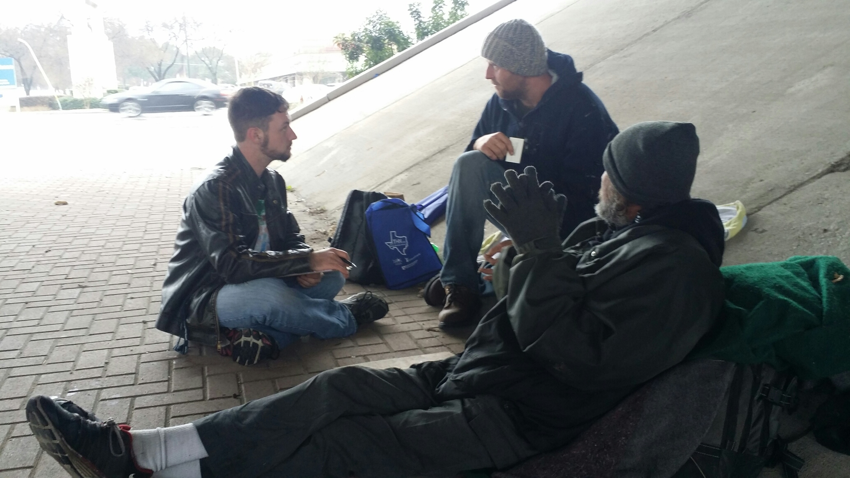
  Volunteers Needed!
  Annual Point-In-Time Count
  What is a Point-In-Time Count?
  A point-in-time count is an unduplicated count on a single night of the people in a community who are experiencing homelessness that includes both sheltered and unsheltered populations. The count also provides an excellent opportunity to increase awareness of homelessness.
  How can I help?
  Do you have a smart phone or a tablet? You can volunteer a few hours to talk to individuals experiencing homelessness and conduct a quick digital survey that will help Texas Homelessness Network and your local homeless service providers better understand the scope of homelessness in your community.
  When is the count?
  The count will be conducted anytime between 12:00am-11:59pm on January 25th 2018. X-we recommend that you put the exact time and shifts your community is going to conduct the PIT.
  
  For more information Please contact:
  X Name
  X Email
  X Phone Number
  X Agency
  X Add any other important PIT information like location, time of count, how to dress, make sure phones/tablets are fully charged on day of count, etc.

