

**Coming Soon…..**

**SOAR Online Course – Child Curriculum!**

**Supplemental Security Income (SSI) for Children:**

Children and individuals under age 18 who are experiencing or are at risk of homelessness (e.g. those aging out of foster care or families who are unable to pay housing expenses) may struggle to access the resources they need. Many have developmental disabilities, serious mental illness, trauma, and medical issues that impact their ability to function. The path to recovery can be extraordinarily challenging when a family is constantly struggling to meet basic needs. Having income and healthcare benefits for children with disabilities is often a crucial first step on the road to recovery. **SSI from the Social Security Administration (SSA) can help**.

The medical evaluation criteria used by SSA to determine disability for children differ markedly from those used by SSA for adults. For adults under age 65, the overarching question is, can they work? For children, SSA evaluates the child’s functional abilities as compared with those of children of the same age who are not disabled.



Because the medical eligibility determination is the least understood and where most applications for SSI fail, the need for community providers to understand the medical criteria for receipt of SSI for children and documenting these criteria in the application is essential.



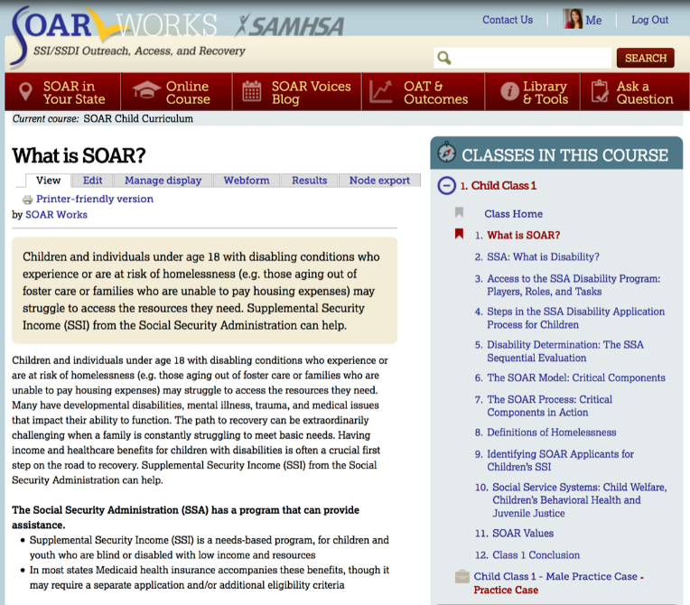

**7 comprehensive classes**



From SOAR 101 to Work Incentives, trainees will learn all they need to know to complete SSI applications for children using the SOAR model.

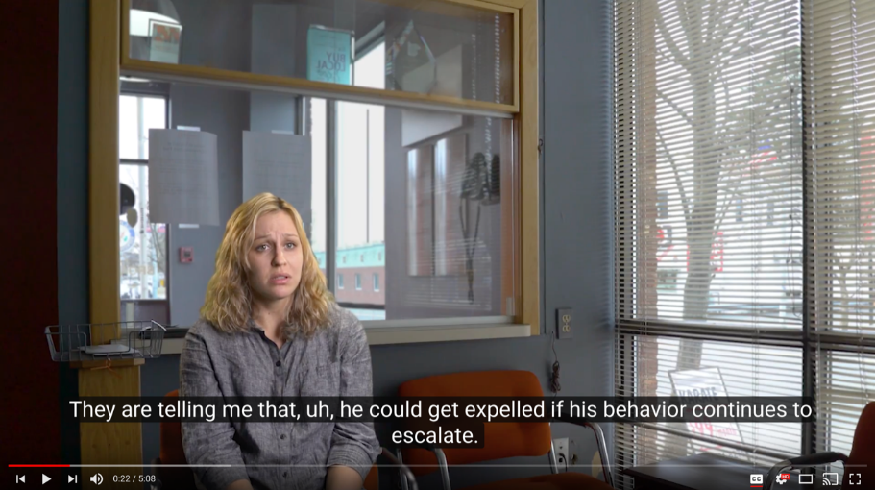**2 fictional   
practice case Applicants**

Trainees will complete an SSI application packet for a fictional child applicant, including a Medical Summary Report (MSR).

