2019 Texas Homeless Network (THN)
Texas Balance of State Continuum of Care (CoC)
Emergency Solutions Grant (ESG) Local Competition
Application Submission Procedures Manual (ASPM)

Table of Contents

Part I: General Application Information 4
1. Emergency Solutions Grant Overview 4
2. General Applicant Eligibility Requirements 4
3. Application and Award Limitations 4
4. Contract Terms 5
5. Application Review Process 5
6. Administrative Deficiencies 6
7. Audit Requirements 8
8. Performance Reviews and Sanctions 9
9. Application Deadline 9
Part II: Application Submission 10
1. Required Format 10
2. Excel Application Document 10
3. PDF Application Document 11
4.Submission Procedure 14
Part III: Application Procedures and Contents 15
1. Application Procedures 20
2. Volume 1 – Applicant Threshold Criteria 21
3. Volume 2 – Uniform Scoring Criteria 22
4. Volume 3 – Street Outreach 23
5. Volume 4 – Emergency Shelter 25
6. Volume 5 – Homeless Prevention 27
7. Volume 6 – Rapid Re-Housing 29
8. Volume 7 – TX BoS CoC Narrative 31
Part IV: Attachments 37
Attachment A: CoC Consultation 38
Attachment B: Written Standards Certification 39
Attachment C: Termination Policy 42
Attachment D: ESG Applicant Certifications 43
Attachment E: Counties and Cities that received ESG funds in 2018 51
Attachment F: Local Government Approval of Shelter Activities 52
Attachment G: TX BoS CoC Collaboration Form Scoring Criteria 53
Attachment H: ESG Expectations Form 54
Attachment I: CoC Collaboration Form 58
Attachment J: TX BoS CoC ESG Local Competition Timeline 60
Attachment K: Grievance Appeal Form 61

Part I: General Application Information

1. Emergency Solutions Grant Overview
    - The State of Texas receives an annual fund allocation from the U.S. Department of Housing and Urban Development (HUD).
    - The McKinney-Vento Homeless Assistance Act as amended by S. 896 The Homeless Emergency Assistance and Rapid Transition to Housing (HEARTH) Act of 2009 authorizes the Emergency Solutions Grant (ESG) Program.
    - The ESG Program is subject to the ESG Interim Regulations at 24 Code of Federal Regulations (CFR) 576.
    - The Texas Department of Housing and Community Affairs’ (TDHCA) Homelessness Programs Rules at 10 Texas Administrative Code (“TAC”) Chapter 7, Subchapter A, govern this Application and Subchapter C in effect at the time the Application is submitted.
    - Additional or ‘cross-cutting’ Federal regulations cited in 24 CFR 576 must also be followed in administering any ESG Program activity.
    - Applicants recommended for funding consideration by The Texas Homeless Network (THN) and approved by the TDHCA Governing Board will execute a written agreement with TDHCA and will agree to comply with all statutory, regulatory, and other legal requirements applicable to the ESG Program as described in the Application.
    - TDHCA and THN provide technical assistance to all ESG Program Applicants to ensure that Applicants understand the State and Federal regulations governing the ESG Program.

2. General Applicant Eligibility Requirements
    - Eligible Applicants are units of general purpose local government and Private Nonprofit Organizations. A Local Redevelopment Authority (LRA) may be an eligible applicant if the LRA is an instrumentality of a unit of general purpose local government, other than a PHA, that is established pursuant to legislation and designated by the chief executive to act on behalf of the local government with regard to ESG activities.
    - Applicants are encouraged to familiarize themselves with TDHCA’s certification and debarment policies per 10 TAC Chapter 2 prior to Application submission.
    - All applicants will be subject to a Previous Participation Review per 10 TAC Chapter Subchapter C.

3. Application and Award Limitations
  - TDHCA funds for ESG are allocated to each Continuum of Care (CoC) region in accordance with the methodology in 10 TAC §7.33(b). The Texas Balance of State Continuum of Care funding availability is $3,332,143.
  - Contract funding limits include the funding request for all Program Participant services proposed in the Application, Homeless Management Information System (HMIS), and Administrative funds.
  - In accordance with the 10 TAC §7.36(a)(2) and 10 TAC §7.33(d), the maximum award amount per Application is as follows:

          - Applicants may not apply for an award of funding in excess of the available funding in the CoC region; The Texas Balance of State Continuum of Care funding availability is $3,332,143.
          - Applicants must apply for an award amount of at least $50,000 and not more than $300,000 for all Program Participant services (Homelessness Prevention, Street Outreach, Emergency Shelter, Rapid Re-housing) proposed in the Application.
          - Funds awarded for HMIS are limited to 12% of the amount of funds awarded for Program Participant services.
          - Administrative activities are limited to three percent of the amount of funds awarded for Program Participant services.
    - Not more than 60% of allocated funds may be awarded for the provision of street outreach and emergency shelter activities.
    - Applicant may request up to 10% of modified total direct costs (MTDC) as defined in 2 CFR §200.68, provided that the Applicant notifies TDHCA of the election to use the 10% MTDC approach with their Application, costs are consistently charged as either indirect or direct costs, and costs are not double charged or inconsistently charged as both.
    - If additional funds become available through deobligated amounts from an award made under the allocation formula or program income generated from an award made under the allocation formula, the funds will be offered to the ESG Subrecipients with active Contracts with the highest expenditure rate, as of the most recent Monthly Expenditure Report. These funds will be offered first to the ESG Subrecipients within the CoC region from which the additional funds became available, and then available statewide. The funds may increase the Contract of an ESG Subrecipient one time by up to 25% of the original Contract amount. Upon Board Approval, TDHCA may elect to reallocate retained funds by this method.

4. Contract Terms
- Any program activity funded under the ESG Program will be governed by a written Contract with TDHCA this contract will identify the terms and conditions related to the awarded funds. The Contract will be effective based on an agreed upon commencement date by all parties, but not prior to approval by the TDHCA governing board. In accordance with 10 TAC §7.41(a), the Contract terms shall not exceed 12 months.
- Performance will be evaluated based on the benchmarks as stated in 10 TAC §7.41(c). Any funds remaining at the end of Contract's close out period will be automatically deobligated. Deobligation of funds may affect future funding recommendations.

5. Application Review Process
    - The Texas Homeless Network will accept Applications on an ongoing basis via a Google Form found here during the Application acceptance period (June 19, 2019 through July 10, 2019). Applications will be reviewed for threshold criteria and selection criteria, administrative deficiencies, and then ranked based upon the self-score of the Application and submitted to TDHCA for previous participation review. Applications will then be reviewed by THN’s Independent Review Team (IRT). Any changes to the self-score ranking by the IRT will be made public by August 23, 2019 on THN’s website and via email.
          - Applications will be accepted by THN beginning on June 19, 2019, at 8:00 a.m. Austin local time. Applications received prior to the commencement of the Application acceptance period will not be accepted.
          - Applications will be accepted by THN on an on-going basis ending July 10, 2019, at 12:00 p.m. Austin local time. Applications received after 12:00 p.m. on July 10, 2019 will not be accepted.
- Each Application will be assigned a Received Date and Time based on the date it is received by THN. Applications received after the Application Deadline will not be accepted, reviewed, or considered for award.
- Applications received are reviewed for eligibility and threshold requirements regarding documentation and compliance with performance on previously awarded Contracts.
- THN will ensure a review of materials required under the NOFA and the Application, and will issue a notice of any administrative deficiencies in accordance with 10 TAC §7.37(b). THN will notify applicants of deficiencies and applicants must provide clarification, correction or non-material missing information to resolve inconsistences in the original application within seven calendar days of administrative deficiency notice by THN.
- All Applicants will be processed through TDHCA’s Previous Participation review, which will include a previous award and past performance evaluation. Poor past performance may disqualify an Applicant for a funding recommendation, or the recommendation may include conditions.
- Recommendations for funding will then be made by the THN’s Independent Review Team the week of August 8, 2019.
- Recommendations for funding must then be approved by the TDHCA’s Executive Award Review and Advisory Committee (EARAC).

6. Administrative Deficiencies
- If an Application contains deficiencies, THN staff may request that the Applicant provide clarification, correction, or non-material missing information to resolve inconsistencies in the original Application or to assist staff in evaluating the Application. THN staff will request clarification or correction in a deficiency notice via an email. Responses are required to be submitted electronically. The time for responding to a deficiency notice commences on the first day of the deficiency notice date. If an administrative deficiency is not resolved to the satisfaction of THN by 5:00 p.m. on the seventh calendar day following the date of the deficiency notice, then one point shall be deducted from the selection criteria score for each additional day the deficiency remains unresolved. If administrative deficiencies are not resolved by 5:00 p.m. Austin local time on the fourteenth calendar day following the date of the deficiency notice, then the Application shall be terminated.
- THN staff may provide an Applicant confirmation that an administrative deficiency response has been received or that such response is satisfactory. Communication from staff that the response was satisfactory does not establish any entitlement eligibility status or to any presumption of having fulfilled any requirements. An Applicant may not change or supplement any part of an Application in any manner after submission to THN, except in response to a direct written request from THN to remedy an administrative deficiency or by amendment of an Application after the Board approval of an ESG award. An administrative deficiency may not be cured if it would, in THN’ determination, substantially change an Application including score, or if the Applicant provides any new unrequested information to cure the deficiency. Pursuant to 10 TAC §7.36(b) an Application must be substantially complete when received by the THN. An Application will be terminated if is so unclear or incomplete that a thorough review cannot reasonably be performed by THN, as determined by THN. Such Application will be terminated without being processed as an administrative deficiency.
- Recommendations for funding will then be presented to TDHCA’s Executive Award and Review Advisory Committee before presentation to the TDHCA Governing Board.
- In accordance with Tex. Gov’t Code §2306.082 and 10 TAC §1.17, it is the TDHCA’s policy to encourage the use of appropriate Alternative Dispute Resolution procedures (ADR) under the Governmental Dispute Resolution Act, Tex. Gov’t Code Chapter 2009, to assist in resolving disputes under the TDHCA’s jurisdiction. As described in Tex. Gov’t Code Chapter 154, Civil Practices and Remedies Code, ADR procedures include mediation.
- THN encourages informal communications between THN staff and Applicants, and other interested persons, to exchange information and informally resolve disputes. THN also has administrative appeals processes to fairly and expeditiously resolve disputes. If at any time an Applicant or other person would like to engage THN in a grievance procedure, the person may send a proposal to THN’s CoC Director at txboscoc@thn.org. The complete Grievance policy is listed below:

Purpose

The purpose of the grievance procedure is to settle any disagreement between an Applicant Organization for the Texas Homeless Network Emergency Solutions Grant (ESG) Local Competition as quickly and impartially as possible, to ensure an efficient, transparent, and fair competition.

Eligibility

A grievance may be filed by any Applicant that claims it has been adversely affected by:
- Improper application of rules, regulations, and/or procedures
concerning participation in the TX BoS CoC’s Program Year 2019 ESG
Application Submission Procedures Manual (ASPM)
- Improper interpretation of rules, regulations, and/or procedures
concerning participation in the TX BoS CoC’s Program Year 2019
ESG Program local application process, as outlined in TX BoS CoC’s Program Year 2019 ESG Application Submission Procedures Manual (ASPM)
- Disparity in the application of rules, regulations, and/or procedures
regarding participation in the TX BoS CoC’s Program Year 2019 ESG Program
application process, as outlined in TX BoS CoC’s Program Year 2019 ESG
Application Submission Procedures Manual (ASPM).
- Violation of rules, regulations, and/or procedures concerning
participation in the TX BoS CoC’s Program Year 2019 ESG Program application
process, as outlined in the TX BoS CoC’s Program Year 2019 ESG
Application Submission Procedures Manual (ASPM).

Procedure for Filing Grievances and Grievance Appeals
The following steps must be taken. Time limits shall begin on the first day after the applicable occurrence, filing, appeal, response, or recommendation. Due to the nature and time constraints of the ESG Program competition, working days shall include weekends and City, County, and/or Federal holidays.

Step 1
- In order to be considered, a grievance must be filed in writing with the
CoC Lead Agency, Texas Homeless Network (THN), within twenty-four
(24) hours of notification of award results. An email clearly stating the
issue and the policy which the Applicant Organization believes was
violated is sufficient to serve as a written grievance. The Applicant
Organization’s grievance email should be sent to the attention of CoC
Director, Sophia Checa, at esg@thn.org. The CoC Lead Agency
has twenty-four (24) hours from receipt of the Applicant Organization’s
grievance email to respond in writing via email in an effort to resolve
the grievance.
Step 2
- If the Applicant Organization is not satisfied with the response received
by the CoC Lead Agency and/or proposed resolution, the Applicant
Organization has twenty-four (24) hours to file a grievance appeal with
the Continuum of Care Board of Directors using the attached official
form found in Attachment K. This written grievance appeal should be
sent to the attention of Dani Shaw, at txboscoc@thn.org. The CoC
Board of Directors has forty-eight (48) hours to investigate and respond
in writing. Applicant Organizations should expect to receive the response via email. The CoC Board of Director’s decision is final and binding.

7. Audit Requirements
    - An applicant is not eligible to receive funds or any other assistance from the TDHCA unless a past Single Audit or Audit Certification Form has been submitted to THN in a satisfactory format in accordance with 10 TAC §1.403. Staff will not recommend Applications for funding unless the Applicant has successfully completed a Previous Participation Review.
  - Applicants are required to have a Unique Entity Identifier Number (UEIN) (previously referred to as a Data Universal Numbering System or DUNS number). A UEIN number is a unique nine-digit identification number provided by the commercial company D&B. Call D&B at 1-844-237-5823 if you do not have a UEIN number or register on line at https://www.dnb.com/duns-number.html and click on “Request a D-U-N-S Number” then follow the directions provided. The process to request a UEIN is short and free of charge.
  - Applicants are also required to register in the System for Award Management (SAM). The SAM is the primary registrant database for the U.S. Federal Government. The SAM collects, validates, stores, and disseminates data in support of agency acquisition missions, including Federal agency Contracts and assistance awards. Please note that the term "assistance awards" includes grants, cooperative agreements and other forms of Federal assistance. Whether applying for assistance awards, Contracts, or other business opportunities, all entities are considered "registrants". Both current and potential Federal government registrants are required to have active registration with the SAM in order to be awarded Contracts by the Federal government. You may register in the SAM at https://sam.gov/SAM. You must have a UEIN number in order to register with the SAM. To register as a new entity, click on “Create A User Account” first to create your account, and then click on “Register Entity” after you created an account.

8. Performance Reviews and Sanctions
THN and TDHCA may review and monitor the performance of Subrecipients in carrying out its responsibilities in accordance with the Contract, 10 TAC Chapters 1 and 2, 7 and 24 CFR 576, and any other applicable Federal and State requirements.

9. Application Deadline
  - The Application must be received THN at the time of Application submission.
  - Applications that do not meet the filing deadline requirements will not be considered for funding. THN will accept Applications from June 19, 2019 until July 10, 2019.
  - Any changes to the competition timeline in this document will be made via email, and posted on the THN website at least 10 days in advance of the change. To sign up for emails related to the TX BoS CoC State ESG Competition, visit the THN website
  - The application timeline is as follows, the timeline can be found in Attachment J.

- June 12, 2019: TX BoS CoC to Host General Meeting on the ESG Local Competition
- June 19, 2019: TX BoS CoC ESG Application Submission Procedures Manual (ASPM) Announced & Application Materials Released on the THN ESG Webpage.
- June 21, 2019: TX BoS ESG Competition Q&A Webinar from 10:00 am CT – 11:30 am CT via Adobe Connect.
June 28, 2019: BoS CoC Consultation Document Due to TX BoS CoC from Applicants at 5:oo pm CST to: esg@thn.org
- July 10, 2019: Submission of all application materials due to THN at 12:00 pm CT via Google Form.
August 8, 2019: Independent Review Team (IRT) to Review Applications
- August 19, 2019: Announcement of Competition Results to Applicants via: email & THN Website
- August 21, 2019: Request for Appeals Due at 5:00 pm CT to: esg@thn.org
- August 23, 2019: THN Submission of results of ESG Coordinator’s Local Competition submitted to TDHCA by 12:00 pm CT

Part II: Application Submission

1. Required Format
  - Applications submitted to THN must be on forms provided by THN and cannot be altered or modified, and must be in final form before submission to THN.
  - One copy of the Application in EXCEL format, and one copy of the Application including all attachments in PDF format must be received by THN by the Application deadline. Both EXCEL and PDF formats must be submitted to constitute an Application. Instructions for how to submit the Applications are described in 4) Submission Procedures of this section.
  - The Applicant is responsible for ensuring that the Application is submitted in the correct format, and that the Application components and files are not corrupted. Applicants are encouraged to contact THN after Application submission but before the Application Deadline to ensure that the files submitted were not corrupt and may be reviewed. Applications files which cannot be opened and reviewed by the THN are not eligible for award.
  - The Application includes multiple volumes and must be submitted with both EXCEL and PDF formats to constitute a completed Application.
  - Hard copy submissions are not an acceptable Application format. Any hard copies received by THN will be confidentially destroyed and will not be considered as an Application for the purposes of review or receipt of an Application.

2. Excel Application Document
  - The Application is a series of EXCEL Workbooks, called Volumes, each consisting of a series of Tabs. Applications must consist of Volumes 1 and 2, and must include at least one additional volume for Program Participant Services (Volumes 3, 4, 5, and/or 6).
          - Volume 1: Threshold Criteria (required for all Applicants)
          - Volume 2: Uniform Scoring (required for all Applicants)
          - Volume 3: Street Outreach (required for Applicants requesting funding under Street Outreach)
          - Volume 4: Emergency Shelter (required for Applicants requesting funding under Emergency Shelter)
          - Volume 5: Homeless Prevention (required for Applicants requesting funding under Homeless Prevention)
          - Volume 6: Rapid Re-housing (required for Applicants requesting funding under Rapid Re-housing)
          - Volume 7: TX BoS CoC Narrative (required for Applicants requesting funding under Street Outreach, Emergency Shelter, Homelessness Prevention and Rapid Re-housing.
  - After you complete the required Application Volumes, save each Volume as an Excel document using the following format. Red lettering indicates Applicant must provide the Applicant’s name; if an Applicant has a common name, such as Catholic Charities or Salvation Army, write the Applicant name and also include the location in which the organization is located:

ESG_Volume_1_APPLICANT_NAME.xlsx
ESG_Volume_2_APPLICANT_NAME.xlsx
ESG_SO_Volume_3_APPLICANT_NAME.xlsx
ESG_ES_Volume_4_APPLICANT_NAME.xlsx
ESG_HP_Volume_5_APPLICANT_NAME.xlsx
ESG_RR_Volume_6_APPLICANT_NAME.xlsx
ESG_TX BoS_Volume 7_APPLICANT_NAME.xlsx

3. PDF Application Document
  - Applicants must submit the excel versions of the Application, along with a PDF version of the Application which includes all required attachments behind each tab. The instructions below are one way to PDF the document, including how to create bookmarks.
  - The PDF Application file is created by converting the EXCEL Workbook file to PDF format. The workbook can be converted using the following steps in Acrobat Pro:
            - Select File, and select Save As Adobe PDF.
            - Select all the “Sheets in Excel” and click Add All under “Sheet Selection” so that all the sheets appears in “Sheets in PDF.” An example is in a screen shot below for Volume 1:

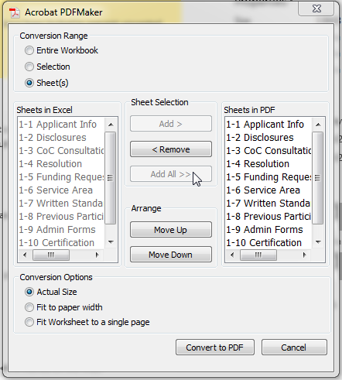
            - Click Convert to PDF. If the Applicant receives the following notification indicating that the PDF will not show comments, the Applicant may select Yes.

            - In the File Name, type a name for each Volume using the following format (red lettering indicates Applicant must provide the Applicant’s name). For Applicants with common names, such as Salvation Army or Catholic Charities, include a dash (-) and the location of the Applicant (city):
ESG_Volume_1_APPLICANT_NAME.pdf
ESG_Volume_2_APPLICANT_NAME.pdf
ESG_Volume_3_ SO_APPLICANT_NAME.pdf
ESG_Volume_4_ES_APPLICANT_NAME.pdf
ESG_Volume_5_HP_APPLICANT_NAME.pdf
ESG_Volume_6_RR_APPLICANT_NAME.pdf
ESG_TX BoS_Volume 7_APPLICANT_NAME.xlsx


  - Remember that there are tabs that require support documentation and/or signatures. Tabs that require additional documentation are noted with a red paperclip symbol that looks like this:

  - Once you have executed all required documents and forms, scan them and insert the scanned documents and forms into the PDF Application file, behind the respective tab.
  - Creating Bookmarks
    - After the Excel file has been converted to PDF and all executed forms have been re-inserted into their appropriate location within the file, you may need to adjust the bookmarks so that each bookmark is named after each spreadsheet tab. Click on the arrow on the left of the PDF, per the screenshot below.
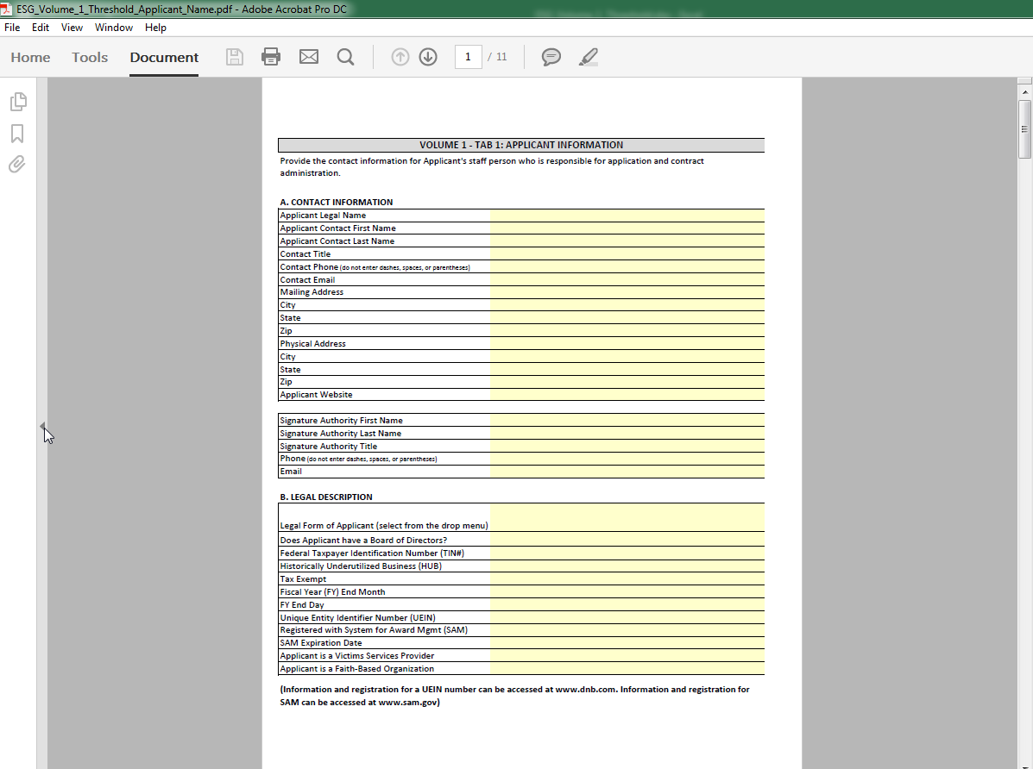
    - After clicking on the arrow, select the bookmark icon on the left to see your bookmarks.
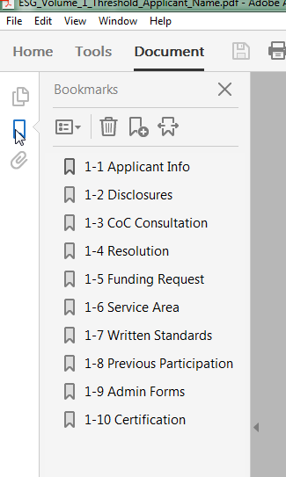

    - If a bookmark has already been created for each tab within the Excel file, you may need to re-set the bookmarks to the correct locations after adding scanned PDF forms. To re-set the location for the bookmarks, go to the first page of each separately labeled form/exhibit. You will then right-click on the corresponding Bookmark for the form/exhibit you are currently viewing. Select Set Destination. A pop-up box will appear asking you the following: "Are you sure you want to set the destination of the selected bookmark to the current location?" Select Yes.
    - If Bookmarks were not already created within the Excel file, you will need to create the Bookmarks. Click the
    - New Bookmark icon which looks like this: 

    - Once all bookmarks are created, select Save.

4.Submission Procedure
One copy of each Application Volume required in EXCEL format, and one copy of each Application Volume required, including all attachments, in PDF format must be uploaded in into the Google Form found here. All application attachments must also be uploaded individually in PDF Format and submitted in the Google Form by the Application Deadline on July 10, 2019 at 12:00 pm.

Google Form Submission Procedure:

- When you open the Google Form please submit your email address on the first page of the application. Then click next.
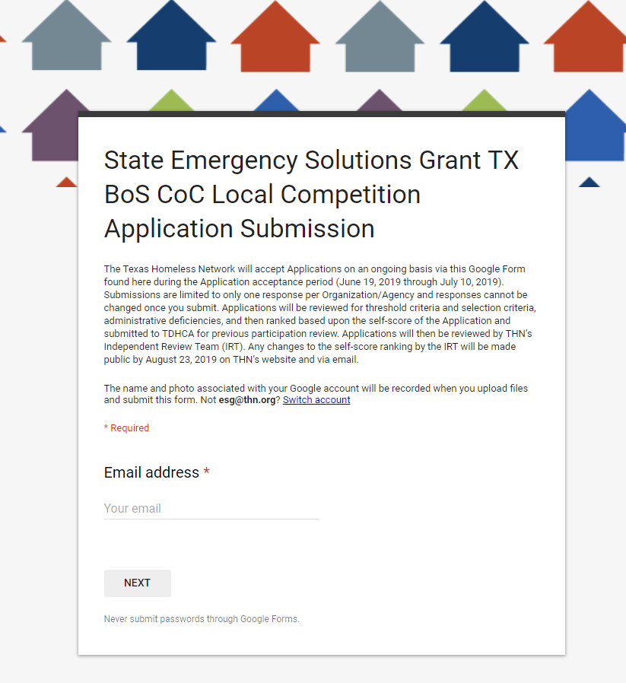

- When you click next you will land on the second part of the Application Submission Form, in this section you will fill out the following information:
  - Your Organization Name
  - Your Application Contact Person
  - Your Application Person Phone Number

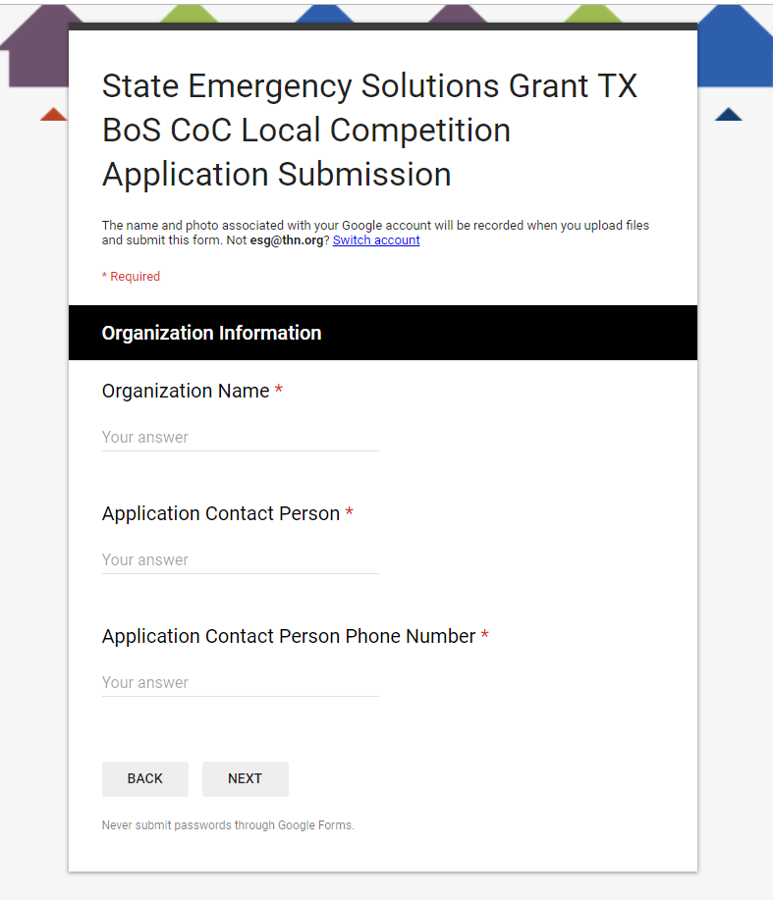

- When you click next you will land on the third part of the Application Submission Form, in this section you will fill out the following information, which is consistent for Volume 1 and Volume 2.
  - Upload PDF Version of Volume Workbook
    - Please upload the complete PDF version of the Excel Workbook with ALL Attachments directly behind the tab calling for it. (All attachments means that this PDF document must include all Excel Tabs as well as the Attachments which have a paperclip.

  - Upload Excel Workbook
    - This upload will consist of ONLY the completed Volume Excel workbook
  - Upload all Attachments individually which pertain to the Excel Workbook which you included in the PDF workbook document.
Volume 1 will include the following attachments, please name PDF’s accordingly:

Volume 1 Individual PDF Names

ESG_Volume_1_APPLICANT_NAME_TAB_2_General Disclosures.pdf
ESG_Volume_1_APPLICANT_NAME_TAB_3_Attachment A.pdf
ESG_Volume_1_APPLICANT_NAME_TAB_4_Resolution.pdf
ESG_Volume_1_APPLICANT_NAME_TAB_5_Indirect Cost Rate.pdf
ESG_Volume_1_APPLICANT_NAME_TAB_7A_Attachment B.pdf
ESG_Volume_1_APPLICANT_NAME_TAB_7B_Attachment C.pdf
ESG_Volume_1_APPLICANT_NAME_TAB_8_PreviousParticipation.pdf
ESG_Volume_1_APPLICANT_NAME_TAB_9_Admin Forms.pdf
ESG_Volume_1_APPLICANT_NAME_TAB_10_Attachment D.pdf

Volume 2 Individual PDF Names

ESG_Volume_2_APPLICANT_NAME_TAB_2_Org Experience.pdf
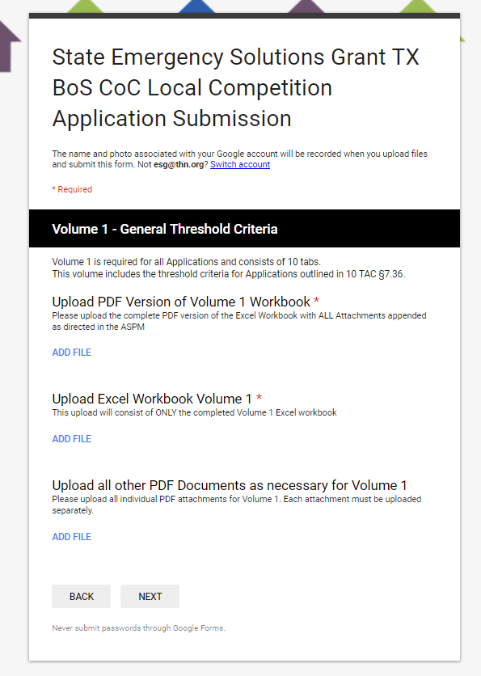

- Next you will land on the fourth part of the Application Submission Form, in this section you will provide information regarding the specific component type. For example: you will be asked if you are applying for street outreach in the first section, if you select “Yes” you will complete the following information, which is consistent for all program participant components which your agency says “Yes” to: Volume 3, Volume 4, Volume 5, Volume 6.

If your agency does not plan to apply for that component, but instead says “No” then your agency will go to the next component type and the same component information will be asked.
  - Like mentioned above, If you select “No” you will move on, but if you select Yes for a component type you will see the following screen which will be consistent for Volumes 3-6.
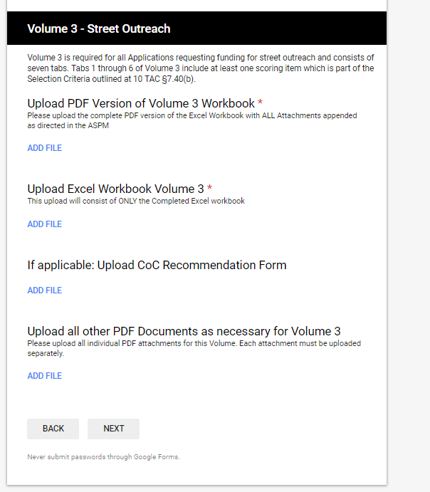
- If you select Yes:
First, begin by uploading the PDF Version of Volume Workbook
    - Please upload the complete PDF version of the Excel Workbook with ALL Attachments directly behind the tab calling for it. (All attachments means that this PDF document must include all Excel Tabs as well as the Attachments, which have a paperclip).

- Upload Excel Workbook
    - This upload will consist of ONLY the completed Volume Excel workbook
- Upload all Attachments individually which pertain to the Excel Workbook which you included in the PDF workbook document.
Volumes 3-6 will include the following PDF’s, please name them accordingly:

Volume 3 Individual PDF Names

Conditional:

ESG_Volume_3_APPLICANT_NAME_TAB_1_Local Government Letter.pdf
ESG_Volume_3_APPLICANT_NAME_TAB_2_Attachment I.pdf
ESG_Volume_3_APPLICANT_NAME_TAB_2_Attachment H.pdf
ESG_Volume_3_APPLICANT_NAME_TAB_6_Experience.pdf

Volume 4 Individual PDF Names

Conditional:

ESG_Volume_4_APPLICANT_NAME_TAB_1_LocalGovernment Letter.pdf
ESG_Volume_4_APPLICANT_NAME_TAB_2_Attachment I.pdf
ESG_Volume_4_APPLICANT_NAME_TAB_2_Attachment H.pdf
ESG_Volume_4_APPLICANT_NAME_TAB_6_Experience.pdf

Volume 5 Individual PDF Names

Conditional:

ESG_Volume_5_APPLICANT_NAME_TAB_1_LocalGovernment Letter.pdf
ESG_Volume_5_APPLICANT_NAME_TAB_2_Attachment I.pdf
ESG_Volume_5_APPLICANT_NAME_TAB_2_Attachment H.pdf
ESG_Volume_5_APPLICANT_NAME_TAB_6_Experience.pdf

Volume 6 Individual PDF Names

Conditional:

ESG_Volume_6_APPLICANT_NAME_TAB_1_LocalGovernment Letter.pdf
ESG_Volume_6_APPLICANT_NAME_TAB_2_Attachment I.pdf
ESG_Volume_6_APPLICANT_NAME_TAB_2_Attachment H.pdf
ESG_Volume_6_APPLICANT_NAME_TAB_6_Experience.pdf

- When you click next you will land on the next part of the Application Submission Form, in this section you will provide information regarding all of your program components in the TX BoS CoC Narrative Volume 7.

Volume 7 Individual PDF Names

Conditional:
ESG_Volume_7_APPLICANT_NAME_AdditionalNarrativeInformation.pdf
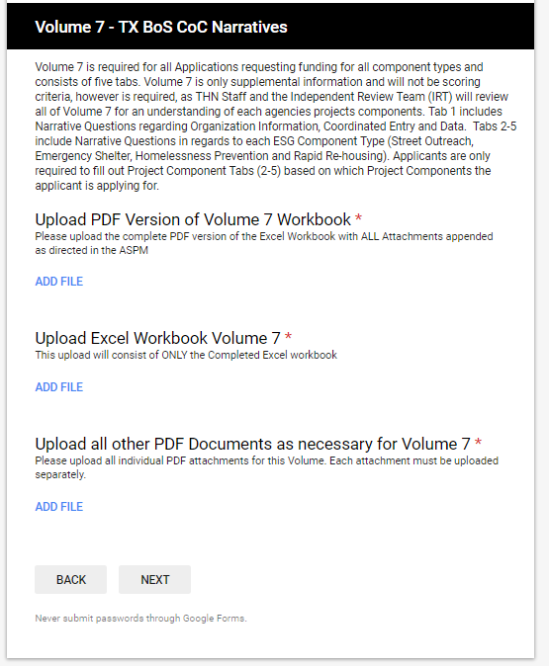

6. When you click next, you will land on the next part of the Application Submission Form, in this section you will upload all attachments necessary to your application including:

- Attachment A
- Attachment B
- Attachment C
- Attachment D
- Conditional: Attachment F
- Attachment H
7. When you click next, you will land on the next part of the Application Submission Form where you will include all Names and Emails of those who are to be notified if awarded.
When you click submit, all of your documentation will then be submitted to THN and you will receive a copy of your answers. You will not be able to re-submit after your first submission.
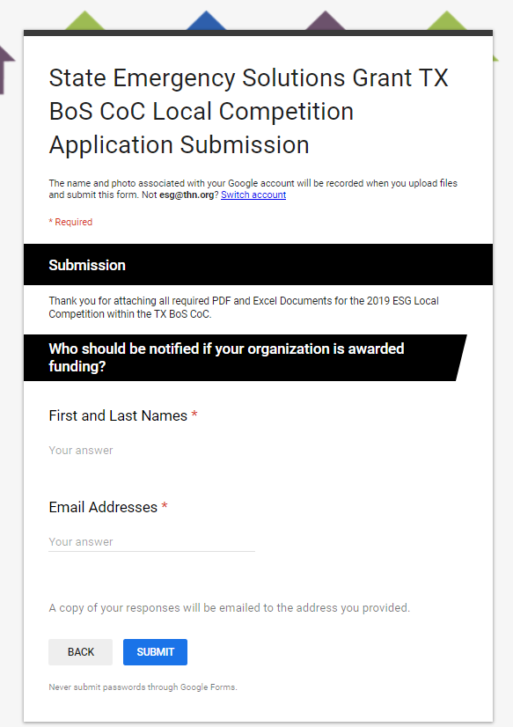

Part III: Application Procedures and Contents

1. Application Procedures
  - Each Application for ESG will consist of Volume 1, Volume 2, Volume 7, plus at least one volume for the Program Participant Service(s) (Volumes 3, 4, 5, and/or 6) for which funds are requested. Volume 1 contains threshold criterion and Volume 2 contains the Uniform Scoring Criteria, which are the same for all Applicants. Volume 7 contains supplemental narrative questions that are required for all Applicants, but are not to be scored.
  - Additional documentation requirements as noted in Part II 3b of this ASPM are only required to be present on the PDF Application Document.

2. Volume 1 – Applicant Threshold Criteria
Volume 1 is required for all Applications and consists of 10 tabs.
This volume includes the threshold criteria for Applications outlined in 10 TAC §7.36.

  - Volume 1 – Tab 1: Applicant Information. This tab is general information about the Applicant. Complete all highlighted fields. The Applicant Legal Name is the full legal name of the entity.
  - Volume 1 – Tab 2: Disclosures. This tab may require submission of a supplemental narrative behind the tab if the Applicant answers “yes” to questions under Part A. Note that question A(ii) includes findings from TDHCA for previous ESG awards. For part B, “technical assistance” refers to attending or viewing the online webinars, or receiving answers to questions asked about the Application.
  - Volume 1 – Tab 3: CoC Consultation. This tab requires submission of a TX BoS CoC Consultation Form confirming consultation with the CoC prior to submission of the entire ESG Application. The form is to be submitted to THN from each agency and can be found as Attachment A to the ASPM. This document must be submitted to THN by June 28, 2019 at 5:00 pm.
  - Volume 1 – Tab 4: Resolution. This tab requires submission of a resolution which includes authorization of submission of the Application and the title of the person authorized to represent the Applicant and designated with signature authority to execute a Contract. The Resolution must be dated no earlier than June 21, 2018.
  - Volume 1 – Tab 5: ESG Funding Request. This tab requests information related to the overall funding request for ESG. Upon selection of the CoC region on Section A of the tab, the total funding limit for the CoC region will populate. The totals entered for each Program Participant Service and their corresponding HMIS and Administrative requests on Section B of the tab will be compared to the total funding available in the region. Section C allows the Applicant to request a Match waiver if the total request is $50,000 in accordance with 10 TAC §7.36(a)(6). If the Applicant plans to use an Indirect Cost Rate, indicate “yes” in Part D and enter the Indirect Cost Rate percentage to be taken. If the Indirect Cost Rate is a negotiated rate with a cognizant federal agency, include the supporting materials behind this tab.
  - Volume 1 – Tab 6: ESG Service Area. The service area for the Application will be reflected in the Contract and activities proposed that are outside of the service area will not be approved. Unless the CoC is not comprised of one or more counties, the service area must consist of one or more counties. If an Applicant wishes to serve counties in two CoCs, that Applicant must submit an Application in each CoC.
  - Volume 1 – Tab 7: Written Standards and Termination Policy.
    - Applicants must submit:
      - a copy of their written standards behind the tab that comply with the requirements of 24 CFR 576§400. If the Applicant is proposing to provide Homelessness Prevention or Rapid Re-housing, the written standards must also include an occupancy standard which does not conflict with Texas Property Code §92.010.
      - A checklist that must be utilized to review the Written Standards prior to submission is included as Attachment B to this ASPM. The checklist must be completed and executed by the Applicant and attached behind this tab.
      - A copy of the Applicant’s policy for termination of assistance that complies with the requirements of 24 CFR §576.402.
      - A certification that the termination policy complies with the requirements of 24 CFR §576.402. A sample certification that may be utilized is included as Attachment C to this ASPM.
  - Volume 1 – Tab 8: Previous Participation. This tab requires submission of the Previous Participation information. Applicants must submit the form located at http://www.tdhca.state.tx.us/pmcomp/forms.htm titled “Uniform Previous Participation Form for Single family and Community Affairs.” Instructions on completing the form are also available at http://www.tdhca.state.tx.us/pmcomp/forms.htm.
  - Volume 1 – Tab 9: Administrative Forms. Required forms for Applications as described in the Application must be submitted behind this tab. Only Applicants that are units of local government are required to submit the environmental form “Part 58 Environmental Review - Exempt or Categorically Excluded (Not Subject to 58.5).” Applicants that are proposing rehabilitation, renovation or conversion will have additional environmental clearance requirements if awarded.
  - Volume 1 – Tab 10: Certification of Applicant. A Certification of Applicant must be submitted behind this tab for each person named as having authority to represent the Applicant and/or execute a Contract. The Certification of Applicant form is included as Attachment D to this ASPM.

3. Volume 2 – Uniform Scoring Criteria
Volume 2 is required for all Applications and consists of 8 tabs. Tabs 1 through 7 of Volume 2 include at least one scoring item which is part of the Uniform Selection Criteria outlined at 10 TAC §7.39.
  - Volume 2 - Tab 1: Homeless Participation. Complete this tab fully. Applicants may select up to three points for persons experiencing or formerly experiencing homelessness participating in a policy-making entity, and/or constructing, renovating, or maintaining ESG Applicant’s ESG facilities.
      - Section A should be completed when requesting up to two points for the organization when the organization includes at least one person who is experiencing Homelessness or formerly experienced Homelessness as a member of or who consults with the policy-making entity. This includes persons who serve on the governing board or council, or who formally consult the board or council though an official channel, such as a committee. Describe the role to reflect this formal membership or consultation in the space provided.
      - Section B should be completed when requesting up to one point for the organization when the organization includes at least one person who is experiencing Homelessness or formerly experienced Homelessness in constructing, renovating, or maintaining the Applicant’s ESG facilities. Describe the role to reflect an eligible person serving in this capacity in the space provided.
  - Volume 2 - Tab 2: Organizational Experience. Applicants may select up to eight points for evidence of applicable organizational or management experience. The required evidence is more fully described in the Application and should be submitted behind this tab. This experience must include current staff. Points will not be awarded under this category for a proposed staff member.
  - Volume 2 – Tab 3: Percentage of Prior ESG Award Expended. Applicants may select up to five points under this criterion only if a minimum of 91% of the prior ESG award was expended on or before the expenditure deadline as described in the Contract during the original term. Contracts that were amended to extend the term may still be eligible to claim points based upon the expenditure percentage as of the original Contract term deadline prior to amendment. All Contracts between TDHCA and the Applicant must be included if the Contract ended on or after June 22, 2018. If the Applicant completed more than one Contract within the specified time period, all Contracts must be included on the tab.
  - Volume 2 – Tab 4: Previous ESG Reporting and Outcomes. Applicants may select up to five points under this criterion based on timeliness of the last three reports and percentage of outcomes met on previous ESG Contracts. All Contracts between TDHCA and the Applicant must be included if the Contract ended on or after June 22, 2018. If the Applicant completed more than one Contract within the specified time period, all Contracts must be included on the tab. If an Applicant had a Subrecipient on previous Contracts, the performance of the overall Contract, including the Subrecipient portion, is included. One point may be selected for each of questions 3-7 as shown in further detail in the Application, totaling four points possible for outcomes. In order to receive one point for each of the performance targets, the average of the Contract(s) target percentages must be 100%. In order to receive one point for timely submissions, the last three reports of each of the Contracts must have been submitted on or before the reporting deadline.
  - Volume 2 – Tab 5: Previous Monitoring Reports. Applicants may select up to five points under this criterion based on previous monitoring history as more fully described in the Application.
  - Volume 2 – Tab 6: Priority for Certain Communities. Applicants may select up to two points under this criterion of their service area for any Program Participant Service includes at least one colonia.
  - Volume 2 – Tab 7: Previously Unserved Areas. Applicants may select up to 10 points under this criterion if the Application proposes to serve an area previously unserved by TDHCA ESG funds or a direct allocation of ESG funds from HUD as more fully described in the Application. A listing of counties which do not qualify as previously unserved areas is included as Attachment E to this ASPM.
  - Volume 2 – Tab 8: Volume 2 Submission Checklist. The checklist is for Volume 2 Application content.

4. Volume 3 – Street Outreach
Volume 3 is required for all Applications requesting funding for street outreach and consists of seven tabs. Tabs 1 through 6 of Volume 3 include at least one scoring item which is part of the Selection Criteria outlined at 10 TAC §7.40(b).
  - Volume 3 – Tab 1: Street Outreach Funding Request and Match.
      - Section A: General Information. Applicant must enter the full legal name of the entity and must select the CoC region under which funds are requested.
      - Section B. Applicant must enter the amount of funds requested for the street outreach Program Participant service. The amount of HMIS for street outreach is limited to 12% of the request for street outreach Program Participant services, and the amount of Administrative funds is limited to 3% of the request for street outreach Program Participant services. The total funds requested for the street outreach award is inclusive of HMIS funds and Administrative funds, and may not exceed the total regional allocation amount.
      - Section C. Applicant must enter the amount of funds that will be used to match the total street outreach award. Note that the Match provided for the street outreach award is not limited to provision of street outreach, but is limited to ESG-eligible activities. The source of the Match contribution may change after a Contract is awarded under the NOFA, but the total Match contribution percentage pledged in the Application will be contractually required.
      - Section D. Applicants may select to receive up to three points under this criterion if the Match proposed exceeds 110% of the requested award for street outreach.
      - Section E. Applicants must identify if any Match provided for street outreach will be utilized for Emergency Shelter. If emergency shelter is proposed as Match, indicate if the emergency shelter will provide overnight shelter. Note that day shelters should meet the requirements outlined in HUD’s ESG Frequently Asked Question: https://www.hudexchange.info/faqs/983/can-a-day-shelter-be-funded-as-an-emergency-shelter-under-esg/. If emergency shelter is a proposed source of Match, nonprofit Applicants must attach a letter affirming local government approval of the shelter activity behind this tab. The local government approval is included as Attachment F in this ASPM. Note that the local government approval is the only part of the Application that may be submitted 30 days after the Application deadline; it is due August 9, 2019.
  - Volume 3 – Tab 2: Continuum of Care Recommendation. Applicants may receive up to 10 points under this scoring criterion as more fully described in the Application. Applicants must submit a CoC Application Scoring Supplement behind this tab if points are requested under this criterion. The TX BoS CoC Collaboration Scoring Criteria can be found in Attachment G of this ASPM. The TX BoS CoC Collaboration Form can be found in Attachment I of this ASPM.
  - Volume 3 – Tab 3: Subpopulations. Applicants may request up to five points based on the percentage of persons served who will be one or more of the Homeless Subpopulations more fully described in the Application. Applicants will enter the total anticipated persons to be served, and the total anticipated persons in one or more Homeless Subpopulations. The percentage calculated will determine the maximum points that may be requested by the Applicant under this criterion.
  - Volume 3 – Tab 4: Outcomes. Applicants may request up to five points based on the percentage of persons to be served with street outreach who will be placed in temporary, transitional, or permanent housing as more fully described in the Application. Applicants must enter the total number of persons anticipated to be placed and the percentage calculated will determine the maximum number of points that may be requested by the Applicant under this criterion.
  - Volume 3 – Tab 5: Services. Applications may receive a maximum of five points based on the number of street outreach services provided though ESG or other funds as more fully described in the Application. Applicants will select the types of services to be provided in order to determine the maximum number of points that may be requested under this scoring criterion.

Note that a referral to another provider is insufficient for the Application to be awarded points under this criterion. Provision of services from outside service providers should be evidenced by a formal agreement, such as a Contract or memorandum of understanding, with the service provider.

  - Volume 3 – Tab 6: Experience Providing Street Outreach. Applications may receive up to 10 points based on experience providing street outreach as further described in the Application. Applicants must attach documentation evidencing that the organization has provided street outreach for the number of years for which points for experience are requested behind the tab. This documentation may include organizational reports, publications, listing of relevant grant awards for street outreach, or any combination of documents that clearly evidence the organizational experience.
  - Volume 3 – Tab 7: Volume 3 Submission Checklist. The checklist is for Volume 3 Application content and includes the total Application self-score for street outreach. Applicants must enter their self-score from Volume 2 – Uniform Selection Criteria (Volume 2 – Tab 8) in order to tally the score that will be utilized to rank the Application for street outreach. In no event will the final score exceed the self-score, inclusive of the score for the Uniform Selection Criteria.

5. Volume 4 – Emergency Shelter
Volume 4 is required for all Applications requesting funding for emergency shelter and consists of seven tabs. Tabs 1 through 6 of Volume 4 includes at least one scoring item which is part of the Selection Criteria outlined at 10 TAC §7.40(c).
  - Volume 4 – Tab 1: Emergency Shelter Funding Request and Match.
      - Section A. Applicant must enter the full legal name of the entity and must select the CoC region under which funds are requested.
      - Section B. The “Emergency Shelter Funds” under Item B will auto-calculate from Section C: “Itemized Emergency Shelter Budget.” Applicant must enter the amount of funds requested for HMIS and Administration for emergency shelter. The amount of HMIS for emergency shelter is limited to 12% of the request for emergency shelter Program Participant funds, and the amount of Administrative funds is limited to 3% of the request for Program Participant emergency shelter funds. The total funds requested for the emergency shelter award is inclusive of HMIS funds and Administrative funds, and may not exceed the total regional allocation amount.
      - Section C. Applicant must enter the itemized amount of funds requested for emergency shelter, exclusive of funds for HMIS and Administration. The itemized amounts for each line item will be summed into the Emergency Shelter Funds requested in Section B.
      - Section D. Applicant must enter the amount of funds that will be used to match the total emergency shelter award. Note that the Match provided for the emergency shelter award is not limited to provision of emergency shelter, but is limited to ESG eligible activities. The source of the Match contribution may change after a Contract is awarded under the NOFA, but the total Match contribution pledged in the Application will be Contractually required if increased Administrative funds are awarded based on the Match pledged at Application.
      - Section E. Applicants may select to receive up to three points under this criterion if the Match proposed exceeds 110% of the requested award for emergency shelter.
      - Section F. Applicants must indicate whether the shelter is an overnight shelter or a day shelter only. Day shelters should meet the requirements outlined in HUD’s ESG FAQ, “Can a day shelter be funded as an emergency shelter under ESG?” at https://www.hudexchange.info/faqs/983/can-a-day-shelter-be-funded-as-an-emergency-shelter-under-esg/. Nonprofit Applicants must attach a letter affirming local government approval of the shelter activity behind this tab. The local government approval is included as Attachment F in this ASPM. Note that the local government approval is the only part of the Application that may be submitted 30 days after the Application deadline; it is due July 21, 2019.
  - Volume 4 – Tab 2: Continuum of Care Recommendation. Applicants may receive up to 10 points under this scoring criterion as more fully described in the Application. Applicants must submit a CoC Application Scoring Supplement behind this tab if points are requested under this criterion. The TX BoS CoC Collaboration Scoring Criteria can be found in Attachment G of this ASPM. The TX BoS CoC Collaboration Form can be found in Attachment I of this ASPM.
  - Volume 4 – Tab 3: Subpopulations. Applicants may request up to five points based on the percentage of persons served who will be one of more of the Homeless Subpopulations more fully described in the Application. Applicants will enter the total anticipated persons to be served, and the total anticipated persons in one or more Homeless Subpopulations. The percentage calculated will determine the maximum points that may be requested by the Applicant under this criterion.
  - Volume 4 – Tab 4: Outcomes. Applicants may request up to five points based on the percentage of persons to be served with emergency shelter who will be placed in permanent housing as more fully described in the Application. Applicants must enter the total number of persons anticipated to be placed and the percentage calculated will determine the maximum number of points that may be requested by the Applicant under this criterion.
  - Volume 4 – Tab 5: Services. Applications may receive a maximum of five points based on the number of emergency shelter services provided though ESG or other funds as more fully described in the Application. Applicants will select the types of services to be provided in order to determine the maximum number of points that may be requested under this scoring criterion. Case management is a required component of emergency shelter.

Note that a referral to another provider is insufficient for the Application to be awarded points under this criterion. Provision of services from outside service providers should be evidenced by a formal agreement, such as a Contract or memorandum of understanding, with the service provider.

  - Volume 4 – Tab 6: Experience Providing Emergency Shelter. Applications may receive up to 10 points based on experience providing emergency shelter as further described in the Application. Applicants must attach documentation evidencing that the organization has provided emergency shelter for the number of years for which points for experience are requested behind the tab. This documentation may include organizational reports, publications, listing of relevant grant awards for emergency shelter, or any combination of documents that clearly evidence the organizational experience.
  - Volume 4 – Tab 7: Volume 4 Submission Checklist. The checklist is for Volume 4 Application content and includes the total Application self-score for emergency shelter. Applicants must enter their self-score from Volume 2 – Uniform Selection Criteria (Volume 2 – Tab 8) in order to tally the score that will be utilized to rank the Application for emergency shelter. In no event will the final score exceed the self-score, inclusive of the score for the Uniform Selection Criteria.

6. Volume 5 – Homeless Prevention
Volume 5 is required for all Applications requesting funding for homeless prevention and consists of seven tabs. Tabs 1 through 6 of Volume 5 includes at least one scoring item which is part of the Selection Criteria outlined at 10 TAC §7.40(d).
  - Volume 5 – Tab 1: Homeless Prevention Funding Request and Match.
      - Section A. Applicant must enter the full legal name of the entity and must select the CoC region under which funds are requested.
      - Section B. The “Homeless Prevention Funds” cell under Item B will auto-calculate from Section C: “Itemized Homeless Prevention Budget.” Applicant must enter the amount of funds requested for HMIS and Administration for homeless prevention. The amount of HMIS for homeless prevention is limited to 12% of the request for Program Participant homeless prevention funds, and the amount of Administrative funds is limited to 3% of the request for homeless prevention Program Participant funds. The total funds requested for the homeless prevention award is inclusive of HMIS funds and Administrative funds, and may not exceed the total regional allocation amount.
      - Section C. Applicant must enter the itemized amount of funds requested for homeless prevention, exclusive of funds for HMIS and Administration. The itemized amounts for each line item will be summed into the Homeless Prevention Funds requested in Section B.
      - Section D. Applicant must enter the amount of funds that will be used to match the total homeless prevention award. Note that the Match provided for the homeless prevention award is not limited to provision of homeless prevention, but is limited to ESG eligible activities. The source of the Match contribution may change after a Contract is awarded under the NOFA, but the total Match contribution pledged in the Application will be Contractually required if increased Administrative funds are awarded based on the Match pledged at Application.
      - Section E. Applicants may select to receive up to three points under this criterion if the Match proposed exceeds 110% of the requested award for homeless prevention.
      - Section F. Applicants must identify if any Match provided for homeless prevention will be utilized for emergency shelter. If emergency shelter is proposed as Match, indicate if the emergency shelter will provide overnight shelter. Note that day shelters should meet the requirements outlined in HUD’s ESG Frequently Asked Question: https://www.hudexchange.info/faqs/983/can-a-day-shelter-be-funded-as-an-emergency-shelter-under-esg/. If emergency shelter is a proposed source of Match, nonprofit Applicants must attach a letter affirming local government approval of the shelter activity behind this tab. The local government approval is included as Attachment F in this ASPM. Note that the local government approval is the only part of the Application that may be submitted 30 days after the Application deadline; it is due July 21, 2019.
  - Volume 5 – Tab 2: Continuum of Care Recommendation. Applicants may receive up to 10 points under this scoring criterion as more fully described in the Application. Applicants must submit a CoC Application Scoring Supplement behind this tab if points are requested under this criterion. The TX BoS CoC Collaboration Scoring Criteria can be found in Attachment G of this ASPM. The TX BoS CoC Collaboration Form can be found in Attachment I of this ASPM.
  - Volume 5 – Tab 3: Subpopulations. Applicants may request up to five points based on the percentage of persons served who will be one of more of the Homeless Subpopulations more fully described in the Application. Applicants will enter the total anticipated persons to be served, and the total anticipated persons in one or more Homeless Subpopulations. The percentage calculated will determine the maximum points that may be requested by the Applicant under this criterion.
  - Volume 5 – Tab 4: Outcomes. Applicants may request up to five points based on the percentage of persons to be served with homeless prevention who will maintain permanent housing as more fully described in the Application. Applicants must enter the total number of persons anticipated to maintain permanent housing for three or more months after exit and the percentage calculated will determine the maximum number of points which may be requested by the Applicant under this criterion.
  - Volume 5 – Tab 5: Services. Applications may receive a maximum of five points based on the number of homeless prevention services provided though ESG or other funds as more fully described in the Application. Applicants will select the types of services to be provided in order to determine the maximum number of points that may be requested under this scoring criterion. Housing stability case management is a required component of homeless prevention, except if the Violence Against Women Act or the Family Violence Prevention and Services Act prohibits certain case management requirements.

Note that a referral to another provider is insufficient for the Application to be awarded points under this criterion. Provision of services from outside service providers should be evidenced by a formal agreement, such as a Contract or memorandum of understanding, with the service provider.

  - Volume 5 – Tab 6: Experience Providing Homeless Prevention or Tenant-Based Rental Assistance. Applications may receive up to 10 points based on experience providing homeless prevention or tenant-based rental assistance as further described in the Application. Applicants must attach documentation evidencing that the organization has provided homeless prevention or tenant-based rental assistance for the number of years for which points for experience are requested behind the tab. This documentation may include organizational reports, publications, listing of relevant grant awards for homeless prevention or tenant-based rental assistance, or any combination of documents that clearly evidence the organizational experience.
  - Volume 5 – Tab 7: Volume 5 Submission Checklist. The checklist is for Volume 5 Application content and includes the total Application self-score for homeless prevention. Applicants must enter their self-score from Volume 2 – Uniform Selection Criteria (Volume 2 – Tab 8) in order to tally the score that will be utilized to rank the Application for homeless prevention. In no event will the final score exceed the self-score, inclusive of the score for the Uniform Selection Criteria.

7. Volume 6 – Rapid Re-Housing
Volume 6 is required for all Applications requesting funding for rapid re-housing and consists of seven tabs. Tabs 1 through 6 of Volume 6 includes at least one scoring item which is part of the Selection Criteria outlined at 10 TAC §7.40(e).
  - Volume 6 – Tab 1: Rapid re-housing Funding Request and Match.
    - Section A. Applicant must enter the full legal name of the entity and must select the CoC region under which funds are requested.
    - Section B. The “Rapid Re-housing Funds” cell under Item B will auto-calculate from Section C: “Itemized Rapid Re-housing Budget.” Applicant must enter the amount of funds requested for HMIS and Administration for rapid re-housing. The amount of HMIS for rapid re-housing is limited to 12% of the request for Program Participant rapid re-housing funds, and the amount of Administrative funds is limited to 3% of the request for Program Participant rapid re-housing funds. The total funds requested for the rapid re-housing award is inclusive of HMIS funds and Administrative funds, and may not exceed the total regional allocation amount.
    - Section C. Applicant must enter the itemized amount of funds requested for rapid re-housing, exclusive of funds for HMIS and Administration. The itemized amounts for each line item will be summed into the Rapid Re-Housing Funds requested in Section B.
    - Section D. Applicant must enter the amount of funds which will be used to match the total rapid re-housing award. Note that the Match provided for the rapid re-housing award is not limited to provision of rapid re-housing, but is limited to ESG eligible activities. The source of the Match contribution may change after a Contract is awarded under the NOFA, but the total Match contribution pledged in the Application will be Contractually required if increased Administrative funds are awarded based on the Match pledged at Application.
    - Section E. Applicants may select to receive up to three points under this criterion if the Match proposed exceeds 110% of the requested award for rapid re-housing.
    - Section F. Applicants must identify if any Match provided for rapid re-housing will be utilized for emergency shelter. If emergency shelter is proposed as Match, indicate if the emergency shelter will provide overnight shelter. Note that day shelters should meet the requirements outlined in HUD’s ESG Frequently Asked Question: https://www.hudexchange.info/faqs/983/can-a-day-shelter-be-funded-as-an-emergency-shelter-under-esg/. If emergency shelter is a proposed source of Match, nonprofit Applicants must attach a letter affirming local government approval of the shelter activity behind this tab. The local government approval is included as Attachment F in this ASPM. Note that the local government approval is the only part of the Application that may be submitted 30 days after the Application deadline; it is due July 21, 2019.
  - Volume 6 – Tab 2: Continuum of Care Recommendation. Applicants may receive up to 10 points under this scoring criterion as more fully described in the Application. Applicants must submit a CoC Application Scoring Supplement behind this tab if points are requested under this criterion. The TX BoS CoC Collaboration Scoring Criteria can be found in Attachment G of this ASPM. The TX BoS CoC Collaboration Form can be found in Attachment I of this ASPM.
  - Volume 6 – Tab 3: Subpopulations. Applicants may request up to five points based on the percentage of persons served who will be one of more of the Homeless Subpopulations more fully described in the Application. Applicants will enter the total anticipated persons to be served, and the total anticipated persons in one or more Homeless Subpopulations. The percentage calculated will determine the maximum points that may be requested by the Applicant under this criterion.
  - Volume 6 – Tab 4: Outcomes. Applicants may request up to five points based on the percentage of persons to be served with rapid re-housing who will maintain permanent housing for three or more months after exit as more fully described in the Application. Applicants must enter the total number of persons anticipated to maintain permanent housing and the percentage calculated will determine the maximum number of points that may be requested by the Applicant under this criterion.
  - Volume 6 – Tab 5: Services. Applications may receive a maximum of five points based on the number of rapid re-housing services provided though ESG or other funds as more fully described in the Application. Applicants will select the types of services to be provided in order to determine the maximum number of points that may be requested under this scoring criterion. Housing stability case management is a required component of rapid re-housing, except if the Violence Against Women Act or the Family Violence Prevention and Services Act prohibits certain case management requirements.

Note that a referral to another provider is insufficient for the Application to be awarded points under this criterion. Provision of services from outside service providers should be evidenced by a formal agreement, such as a Contract or memorandum of understanding, with the service provider.

  - Volume 6 – Tab 6: Experience Providing Rapid Re-housing or Tenant-Based Rental Assistance. Applicants may receive up to 10 points based on experience providing rapid re-housing or tenant-based rental assistance as further described in the Application. Applicants must attach documentation evidencing that the organization has provided rapid re-housing or tenant-based rental assistance for the number of years for which points for experience are requested behind the tab. This documentation may include organizational reports, publications, listing of relevant grant awards for rapid re-housing or tenant-based rental assistance, or any combination of documents that clearly evidence the organizational experience.
  - Volume 6 – Tab 7: Volume 6 Submission Checklist. The checklist is for Volume 6 Application content and includes the total Application self-score for rapid re-housing. Applicants must enter their self-score from Volume 2 – Uniform Selection Criteria (Volume 2 – Tab 8) in order to tally the score that will be utilized to rank the Application for rapid re-housing. In no event will the final score exceed the self-score, inclusive of the score for the Uniform Selection Criteria.

8. Volume 7 – TX BoS CoC Narrative

Volume 7 is required for all Applications requesting funding for all component types and consists of five tabs. Volume 7 is supplemental information and will not be scored, however is required, as THN Staff and the Independent Review Team (IRT) will review Volume 7 for an understanding of each agencies projects component(s).

Tab 1 includes Narrative Questions regarding Organization Information, Coordinated Entry and Data. Tabs 2-5 include Narrative Questions in regards to each ESG Component Type (Street Outreach, Emergency Shelter, Homelessness Prevention and Rapid Re-housing). Applicants are only required to fill out Project Component Tabs (2-5) based on which Project Components the applicant is applying for.

  - VOLUME 7 - TAB 1: All Program Component Narrative Questions

    - Section 1 Organization Information Component Narrative Questions
Applicants are to provide information regarding the Organization who is applying for ESG Funding. There are no limits to the length of the responses on questions one through four however; each response must fully answer the question.
- What is your organization’s mission statement?
- Does the project, which you are applying for fit within the mission of your organization? Does the organization currently serve homeless households in the proposed coverage area?
- How long has the Organization had its 501 (c) (3) status? If your organization is a government entity, enter N/A.
- Does the program have staff capacity to adequately administer the ESG program without a heavy reliance on volunteers?
  - If your agency relies heavily on volunteers, please identify the number of full-time volunteers that will be dedicated to ESG in your agency.
    - Section 2: Coordinated Entry Component Narrative Questions
*Responses to the questions below are required for organizations applying for Street Outreach (SO), Emergency Shelter (ES) and/or Rapid Re-housing (RRH) funding. If your organization is not currently participating in Coordinated Entry, please use this section to talk about how you plan to help implement Coordinated Entry into your community.
              - For SO/ES/RRH, please describe your involvement in the implementation of the local Coordinated Entry System.
              - For SO/ES/RRH, does your organization participate in the Coordinated Entry System? Meaning that there are currently trained assessors on staff at the organization, or your organization is active in the implementation of the local Coordinated Entry System or if there is not an operational Coordinated Entry System, does your organization intend to participate in leading the implementation?

    - Section 3: Data Component Narrative Questions
              - Does your organization collect all Universal Data Elements and use (Homeless Information Management System) HMIS (or a comparable database for Victim Service Providers) that allows the user to enter the information?
              - Does the agency have an adequate plan to ensure compliance with HMIS requirements (or comparable database), including staffing, data entry, and data quality standards, that includes oversight by agency administration?

    - Section 4: HMIS (for non-DV and non-victim service providers only) Component Narrative Questions
*Responses to the question below are only for agencies who do are not domestic violence providers
              - Does the agency have an HMIS Agency Administrator (or other designee) to enter data, pull reports, and attend all mandatory HMIS trainings?

    - Section 5: Domestic Violence (DV) HMIS Comparable Database (For DV and victims service providers only) Component Narrative Questions
*Responses to the question below are only for agencies who are DV providers.
              - Can the comparable database the agency uses produce the ESG CAPER directly from the database? If not, is your agency committed to having a comparable database capable of complying with reporting requirements prior to project start date?

b) Volume 7 – Tab 2: Street Outreach
Volume 7 – Tab 2 is required for all Applications requesting funding for Street Outreach. Volume 7 Tab 2 is only supplemental information and will not be scoring criteria, however is required, as THN Staff and the Independent Review Team (IRT) will review all of Volume 7 for an understanding of each agencies projects components. Please Note: Applicants are only required to fill out Project Component Tabs (2-5) based on which Project Components the applicant is applying for.
I. Section 1: Street Outreach Component Narrative Questions
            - Please describe how your organizations ESG funded Street Outreach program will engage unsheltered households with high barriers and connect them to emergency services and permanent housing through Coordinated Entry?
            - Will this project fill a gap in the community, by serving an underserved population, providing services that are not provided by other agencies or organizations, or serving an under-served area? If so, please describe.
            - Explain why ESG funds are necessary and appropriate for this Street Outreach Project?
            - If this project is not awarded, what is your community's plan to meet this need?
            - Will the project screen out or terminate participants for any reason? If yes, please give the reasoning for why a participant may be screened out or terminated.
II. Section 2: Street Outreach Project Performance (Only applicants who had Program Year 2018 Street Outreach Funding)
            - What was the percentage of exits to permanent housing (# of exits to permanent housing ÷ total # of persons served) Please answer with either: 40%+, 35-39% or below 35% of exits. *You can check one response by highlighting your answer in a yellow color.

c) Volume 7 – Tab 3: Emergency Shelter
Volume 7 – Tab 3 is required for all Applications requesting funding for Emergency Shelter. Volume 7 Tab 3 is only supplemental information and will not be scoring criteria, however is required, as THN Staff and the Independent Review Team (IRT) will review all of Volume 7 for an understanding of each agencies projects components. Please Note: Applicants are only required to fill out Project Component Tabs (2-5) based on which Project Components the applicant is applying for.

I. Section 1: Emergency Shelter Component Narrative Questions
            - Please describe how your organizations ESG funded Emergency Shelter Project will ensure that all participants can access this emergency shelter regardless of Gender Identity?
            - Will this project fill a gap in the community, by serving an underserved population, providing services that are not provided by other agencies, or serving an under-served area? If so, please describe.
            - Explain why ESG funds are necessary and appropriate for this Emergency Shelter Project?
            - Is Emergency Shelter possible in your community without ESG funding? If no, what are the plans should this project not be funded?
            - Is the project housing-focused? Does the project actively connect shelter residents to permanent housing by focusing all services toward helping participants find permanent housing options?
            - Are shelter services voluntary?
            - Do residents have to meet any pre-requisites before the shelter will assist with connecting them to permanent housing?
            - Will the project screen out or terminate participants for any reason? If yes, please give the reasoning for why a participant may be screened out or terminated.
            - Is the project connected to or does your organization provide rapid re-housing and permanent supportive housing programs? If so, please describe the connection.

II. Section 2: Emergency Shelter Project Performance (Only applicants who had Program Year 2018 Emergency Shelter Funding)
            - What was the percentage of exits to permanent housing (# of exits to permanent housing ÷ total # of persons served) Please answer with either: 40%+, 35-39% or below 35% of exits. *You can check one response by highlighting your answer in a yellow color.

d) Volume 7 – Tab 4: Homelessness Prevention
Volume 7 – Tab 4 is required for all Applications requesting funding for Homelessness Prevention Volume 7 Tab 4 is only supplemental information and will not be scoring criteria, however is required, as THN Staff and the Independent Review Team (IRT) will review all of Volume 7 for an understanding of each agencies projects components. Please Note: Applicants are only required to fill out Project Component Tabs (2-5) based on which Project Components the applicant is applying for.
I. Section 1: Homelessness Prevention Component Narrative Questions
            - Please describe how your organization will utilize ESG Homelessness Prevention Funding?
            - Does the project use its homelessness prevention funds exclusively to prevent returns to homelessness among former clients of rapid rehousing or permanent supportive housing programs?
            - Explain why ESG funds are necessary and appropriate for this Homelessness Prevention Project?
            - Does your organization screen out or terminate participants for any reason? If yes, please give the reasoning for why a participant may be screened out or terminated.
            - Does the project have dedicated staff whose responsibility is to identify and recruit landlords and encourage them to rent to homeless households served by the program?
            - Does the project use a progressive engagement approach, where financial assistance is not a standard package and is flexible enough to adjust to households’ unique needs?
            - Is participation in services voluntary?

II. Section 2: Homelessness Prevention Project Performance (Only applicants who had Program Year 2018 Homelessness Prevention Funding)
            - What was the percentage of exits to permanent housing (# of exits to permanent housing ÷ total # of persons served) Please answer with either: 40%+, 35-39% or below 35% of exits. *You can check one response by highlighting your answer in a yellow color.

e) Volume 7 – Tab 5: Rapid Re-housing
Volume 7 – Tab 5 is required for all Applications requesting funding for Rapid Re-housing. Volume 7 Tab 2 is only supplemental information and will not be scoring criteria, however is required, as THN Staff and the Independent Review Team (IRT) will review all of Volume 7 for an understanding of each agencies projects components. Please Note: Applicants are only required to fill out Project Component Tabs (2-5) based on which Project Components the applicant is applying for.
I. Section 1: Rapid Re-housing Component Narrative Questions
            - Please describe how this ESG Rapid Rehousing Funding will be used.
            - Does the agency provide assistance for paying security deposits, last month’s rent, utility deposits, utility payments, moving costs, housing search, housing stability case management, mediation, rental assistance and arrears?
            - Does the project have an adequate plan to ensure access to unsheltered individuals and/or families?
            - Is the project low barrier, meaning the project assumes all participants are ready for housing and does not require participants to meet prerequisites, other than HUD-mandated eligibility, before entering the program?
            - Does your organization screen out or terminate participants for any reason? If yes, please give the reasoning for why a participant may be screened out or terminated.
            - Does the project provide active and assertive support to help participants find housing, including calling landlords on their behalf, visiting properties with clients, transporting participants to housing and other stability appointments, and negotiating with landlords?
            - Does the project have dedicated staff whose responsibility is to identify and recruit landlords and encourage them to rent to homeless households served by the program?
            - Does the project use a progressive engagement approach, where financial assistance is not a standard package and is flexible enough to adjust to households’ unique needs?
            - Is participation in services voluntary?

II. Section 2: Rapid Re-housing Project Performance (Only applicants who had Program Year 2018 Street Outreach Funding)
            - What was the percentage of exits to permanent housing (# of exits to permanent housing ÷ total # of persons served) Please answer with either: 40%+, 35-39% or below 35% of exits. *You can check one response by highlighting your answer in a yellow color.

Part IV: Attachments

Attachment A: CoC Consultation
2019 Emergency Solutions Grants (ESG) Program Application
Volume 1, Tab 3: Consultation with Continuum of Care Lead Agency
Name of ESG Applicant:
CoC Region Number #: TX-607
CoC region name: Texas Balance of State Continuum of Care (TX BoS CoC)

Per 10 Texas Administrative Code (TAC) §7.36: (a) Applications submitted to THN in response to the ESG Local Competition are subject to TDHCA’s general threshold criteria. Applications which do not meet the general threshold criteria or which cannot resolve an administrative deficiency related to general threshold criteria are subject to termination. Under TDHCA’s Allocation Formula, evidence from the CoC Lead Agency (THN) in the region that the Applicant consulted with the CoC in the preparation of their ESG application and that the CoC Lead Agency agrees that the Application meets CoC priorities for serving persons experiencing homelessness and/or persons At-risk of Homelessness.
To be completed by the CoC Lead Agency Staff:
- Did the Applicant consult with the CoC Lead Agency in the preparation of their ESG Application?
Yes No
- Does the CoC Lead Agency agree that the Application meets CoC priorities for serving persons experiencing homelessness and/or persons At-risk of Homelessness?
Yes No

Name of CoC Staff (please print or type)

Signature of CoC Staff Date

Email of CoC Staff Phone of CoC Staff

Attachment B: Written Standards Certification

2019 Emergency Solutions Grants (ESG) Program Application
Volume 1, Tab 7a: Written Standards Certification

Name of ESG Applicant:
CoC region #: TX-607
CoC region name: Texas Balance of State Continuum of Care (TX BoS CoC)

I, name, title, am authorized to act on behalf of the ESG Applicant and certify that the ESG Applicant has written standards that comply with the requirements of 24 CFR §576.400 and the TDHCA One-Year Action Plan, including, but not limited to the following as applicable for the services provided:
- Evaluation (24 CFR §576.400(e)(3)(i))
  - Definitions of homeless or at-risk of homelessness are included in the evaluation.
  - Standard policies and procedures for evaluating individual and household eligibility for ESG are present.
  - Priority populations are listed, and priority populations listed are the same as the Continuum of Care priority populations.

- Targeting - 24 CFR §576.400(e)(3)(ii),(iv)
  - Standards for targeting and providing essential services related to street outreach are present.
  - Standards determining how providers will assess, prioritize, and reassess participant's needs for essential services related to emergency shelter are present.

- Evaluation for Emergency Shelter - 24 CFR §576.400(e)(3)(iii)
  - There a description of:
    - Clients that will be admitted?
    - Clients that will be diverted?
    - Clients that will be referred?
    - Clients will be discharged.

  - There are safeguards to secure safety (if applicable).
  - There are reasonable accommodations for persons with disabilities included.
- Coordination - 24 CFR §576.400(e)(3)(v)
  - There are policies and procedures for coordination among:
    - Emergency shelter providers;
    - Essential service providers;
    - Homelessness prevention providers;
    - Rapid re-housing assistance providers;
    - Other homeless assistance providers; and
    - Mainstream services and housing providers.
- Assistance Levels - 24 CFR §576.400(e)(3)(vi)
  - The following descriptions are included:
    - Clients will receive rapid re-housing or homelessness prevention;
    - Whether a percentage or amount of rent will be paid by client;
    - Whether a percentage or amount of utilities will be paid by client;
    - Term of rental assistance;
    - How or if rental assistance be adjusted over time;
    - Amount of assistance will be provided;
    - How the duration of assistance be determined;
    - What happens after a break in service (i.e., Program participant stops receiving assistance one month);
    - What unit sizes are appropriate for rapid re-housing? (Any occupancy standard set by the ESG Applicant in its written standards does not conflict with local regulations or Texas Property Code §92.010. Texas Property Code §92.010 states that, with certain exceptions as outlined in the Texas Property Code, the maximum number of adults that a landlord may allow to occupy a dwelling is three times the number of bedrooms in the dwelling.); and
    - What data sources/formats are used for rent reasonableness.

- Housing Stability Case Management/Relocation Services – 24 CFR §576.400(e)(3)(ix)
  - The following descriptions are included:
    - Types of services offered and not offered;
    - Amounts offered for the services;
    - Term of provision of case management/relocation services;
    - Inclusion of monthly meetings to assist with housing stability? (n/a for Domestic Violence providers);
    - Inclusion of planning for the client to retain permanent housing once ESG assistance ends? (n/a for Domestic Violence providers); and
    - Inclusion of assistance for program participants’ access supportive services for which they may be eligible? (n/a for Domestic Violence providers).

- Relocation Services: Financial – 24 CFR §576.105(a)
  - Written standards specify when the following financial assistance is offered or not offered:
    - Rental application fees;
    - Security deposits/Last month’s rent;
    - Utility deposits/payments;
    - Moving costs; and
    - Storage fees (3 months maximum).

- Service Costs (Include if services are offered and which community organizations can act as a referral source, if applicable) – 24 CFR §576.105(b)(3)-(5)
  - Written standards specify when the following services are offered or not offered, and which community resources can be used:
    - Mediation;
    - Legal Services; and
    - Credit Repair.

- Denials 24 CFR §576.402
  - There are policies and procedures for terminating assistance.
  - The appeal process includes notification of denial, the household’s process to appeal the decision, and the appeal process includes the record keeping process for denial requests.

Name of Authorized Person

Authorized Signature Date

Title

Attachment C: Termination Policy
2019 Emergency Solutions Grants (ESG) Program Application
Volume 1, Tab 7b: Termination Policy Certification
Name of ESG Applicant:
CoC region #: TX-607
CoC region name: Texas Balance of State Continuum of Care (TX BoS CoC)

I, name, title, am authorized to act on behalf of the ESG Applicant and certify that:
- The ESG Applicant has a termination policy that complies with the requirements of 24 CFR §576.402, including, but not limited to:
  - Establishing a formal process that recognizes the rights of the individuals affected;
  - Examining all extenuating circumstances in determining when violations warrant termination so that a program participant's assistance is terminated only in the most severe cases;
  - In the case of rental assistance, providing:
    - Written notice to the program participant containing a clear statement of the reasons for termination;
    - A review of the decision, in which the program participant is given the opportunity to present written or oral objections before a person other than the person (or a subordinate of that person) who made or approved the termination decision; and
    - Prompt written notice of the final decision to the program participant.
  - Allowing the ESG Applicant to provide the program participant(s) assistance at a later date.

Name of Authorized Person

Authorized Signature Date

Title

Attachment D: ESG Applicant Certifications
2019 Emergency Solutions Grants (ESG) Program Application
Volume 1, Tab 10: ESG Certifications

I, Name, Title, am authorized to act on behalf of eligible entity applying for ESG funds, to certify that:
Legal Authority - The Applicant possesses legal authority to apply for and receive funds and carry out activities authorized by the Emergency Solutions Grants Program.
Matching Funds - The Applicant will provide the matching funds required by, and compliant with, 24 CFR §576.20, including a description of the sources and amounts of such supplemental funds.
Discharge Policy - The Applicant will participate in the development and implementation of, to the maximum extent practicable and where appropriate, policies and protocols for the discharge of persons from publicly funded institutions and systems of care (such as health care facilities, foster care or other youth facilities, or correction programs and institutions) in order to prevent such discharge immediately resulting in homelessness for such persons.
Confidentiality – The Applicant has or shall develop and implement procedures to ensure the confidentiality of records pertaining to any individual provided family violence prevention or treatment services under any project assisted under this Contract, and that the address or location of any family violence shelter project assisted will, except with written authorization of the person or persons responsible for the operation of such shelter, not be made public.
Affirmatively Furthering Fair Housing - The Applicant will ensure that it will use these funds in a manner that follows the State of Texas’ Analysis of Impediments and Applicant will maintain records in this regard.
Section 3 - The Applicant will comply with Section 3 of the Housing and Urban Development Act of 1968, and implementing regulations at 24 CFR Part 135, except that homeless individuals have priority over other Section 3 residents in accordance with 24 CFR § 576.405(c).
Certification Regarding Lobbying
- No Federal appropriated funds have been paid or will be paid, by or on behalf of the State, to any person for influencing or attempting to influence an officer or employee of any agency, a Member of Congress, an officer or employee of Congress, or an employee of a Member of Congress in connection with the awarding of any Federal loan, the entering into of any cooperative agreement, and the extension, continuation, renewal, amendment, or modification of any Federal contract, grant, loan, or cooperative agreement.
- If any funds other than Federal appropriated funds have been paid or will be paid to any person for influencing or attempting to influence an officer or employee of any agency, a Member of Congress, an officer or employee of Congress, or an employee of a Member of Congress in connection with this Federal contract, grant, loan, or cooperative agreement, the State shall complete and submit Standard Form-LLL, "Disclosure Form to Report Lobbying," in accordance with its instructions.
- The Applicant confirms that the language of this certification shall be included in the award documents for all subawards at all tiers (including subcontracts and contracts under grants, loans, and cooperative agreements) and that all subawards shall certify and disclose according to the Government-wide Guidance for New Restrictions on Lobbying (Fed. Reg. December 20, 1989; 52306).

Major rehabilitation/conversion – If an emergency shelter’s rehabilitation costs exceed 75 percent of the value of the building before rehabilitation (regardless of the amount of ESG funds used), the building will be maintained as a shelter for homeless individuals and families for a minimum of 10 years after the date the building is first occupied by a homeless individual or family after the completed rehabilitation. If the cost to convert a building into an emergency shelter exceeds 75 percent of the value of the building after conversion, the building will be maintained as a shelter for individuals experiencing homelessness and families for a minimum of 10 years after the date the building is first occupied by a homeless individual or family after the completed conversion. In all other cases where ESG funds are used for renovation, the building will be maintained as a shelter for homeless individuals and families for a minimum of 3 years after the date the building is first occupied by an individual or family experiencing homelessness after the completed renovation. The Applicant will enter into a Land Use Restriction Agreement (“LURA”) to use the building as an emergency shelter for the amount of time determined in 24 CFR §576.102(c), and further explained in 10 TAC §7.3.
Essential Services and Operating Costs – If ESG funds are used for shelter operations or essential services related to street outreach or emergency shelter, the Applicant will provide services or shelter to homeless individuals and families for the period during which the ESG assistance is provided, without regard to a particular site or structure, so long as the Applicant serves the same type of persons (e.g., families with children, unaccompanied youth, veterans, disabled individuals, or victims of domestic violence) or persons in the same geographic area.
Supportive Services – The Applicant will assist individuals experiencing homelessness in obtaining permanent housing, appropriate supportive services (including medical and mental health treatment, counseling, supervision, and other services essential for achieving independent living), and other Federal State, local, and private assistance available for such individuals.
Homeless Persons Involvement - If this Application is funded, homeless individuals and families should be involved, to the maximum extent practicable, through employment, volunteer services, or otherwise, in constructing, renovating, maintaining, and operating facilities assisted under ESG, in providing services assisted under ESG, and in providing services for occupants of facilities assisted under ESG.
No Violation of Federal Law - The Applicant certifies that this Application does not include proposed financial participation by a person who, during the five-year period preceding the date of the Application, has been convicted of violating a federal law or assessed a penalty in a federal civil or administrative enforcement action in connection with a contract awarded by the federal government as a result of Hurricane Rita, Hurricane Katrina, or any other disaster occurring after September 24, 2005.
Obligation Period – A Unit of government that is selected for funding must obligate ESG funds within 120 days from the date it receives an award letter from TDHCA.
Drug-Free Shelter/Workplace – The Applicant will have a policy designed to ensure that the homeless facility is free from the illegal use, possession, or distribution of drugs or alcohol by its beneficiaries. The Applicant organization will ensure compliance with the Drug-Free Workplace Act of 1988.
HMIS Participation, 24 CFR §576.400(f) – The Applicant organization will meet HUD’s standards for participation in a local Homeless Management Information System (HMIS) or comparable database (for Victim Services Providers and Legal Services Providers) and its standards for the collection and reporting of client-level information.
The Applicant organization will produce a report from HMIS an upload-required information into the SAGE reporting system for the Consolidated Annual Performance Evaluation and Report.
Coordination with other Targeted Homeless Services, 24 CFR §576.400(b) – The Applicant must coordinate and integrate, to the maximum extent practicable, ESG-funded activities with other programs targeted to homeless people in the area covered by the Continuum of Care or area over which the services are coordinated to provide a strategic, community-wide system to prevent and end homelessness for that area.

System and Program Coordination with Mainstream resources, 24 CFR §576.400(c) – The Applicant must coordinate and integrate, to the maximum extent practicable, ESG funded activities with mainstream housing, health, social services, employment, education, and youth programs for which families and individuals at risk of homelessness and homeless individuals and families may be eligible. Refer to 24 CFR §576.400(b) for a list of mainstream resources to coordinate ESG activities.

Centralized or Coordinated Assessment, 24 CFR §576.400(d) – CoCs are required to establish a centralized or coordinated assessment system. Applicant will be required to participate in the centralized system. Applicant must maintain evidence of the use of, and written intake procedures for, the centralized or coordinated assessment systems(s) developed by the Continuum of Care. If Applicant is a legal or a victim service provider choosing not to use the CoC centralized or coordinated assessment system, Applicant must have and consistently apply written standards for assessment.

Written Standards for Providing ESG Assistance, 24 CFR §576.400(e) – The Applicant must establish and consistently apply within the Applicant’s program, written standards for providing ESG assistance. If an Applicant is awarded funds, the selected Applicant must provide TDHCA and THN a copy of the written standards for providing ESG assistance prior to contract execution. Refer to 24 CFR §576.400(d) for a discussion of the written standards.

Evaluation of Program Participant Eligibility and Needs, 24 CFR §576.401 – The applicant must conduct an initial evaluation to determine the eligibility of each individual or family’s eligibility for ESG assistance and the amount and types of assistance the individual or family needs to regain stability into permanent housing. These evaluations must be conducted in accordance with the centralized or coordinated assessment requirements set forth under 24 CFR §576.400(d) and the written standards established under 24 CFR §576.400(e) and all the guidelines outlined on 24 CFR §576.401(a).
Terminating Assistance, 24 CFR §576.402 – If a program participant who receives ESG assistance violates program requirements, the Applicant may terminate the assistance in accordance with a formal process established by the Applicant that protects the rights of the individuals affected. Therefore, a formal process must be in place. This applies to all forms of ESG assistance. For more information, refer to the guidelines outlined in 24 CFR §576.402.

Shelter and Housing Standards, 24 CFR §576.403 – The Applicant is responsible for the performance of inspections to ensure that shelter and housing occupied by ESG participants meets the following standards.

- Lead Based Paint Act, 24 CFR §576.403(a) – Lead-based paint remediation and disclosure applies to all ESG-funded shelters and all housing occupied by ESG participants. The Lead-Based Paint Poisoning Prevention Act (42 U.S.C. 4821-4846), the Residential Lead-Based Paint Hazard Reduction Act of 1992 (42 U.S.C 4851-4856), and the relevant subparts of the implementing regulations at 24 CFR Part 35, Subparts A, B, H, J, K, M and R apply to activities under this grant program. The Applicant must also comply with the Lead, Renovation, Repair, and Painting Program Final Rule, 40 CFR Part 745, where applicable.
- Minimum Standards for Emergency Shelters and for permanent housing, 24 CFR §576.403(b)&(c) – Emergency shelters that receive assistance for shelter operations are required to meet habitability standards. If ESG funds are used to help a program participant remain in or move into permanent housing, that housing must also meet habitability standards. The minimum standard for emergency shelters and permanent housing include standards for structure and material, access, space and security, interior air quality, water supply, sanitary facilities, thermal environment, illumination and electricity, food preparation, sanitary conditions and fire safety. Shelters renovated with ESG funds are also required to meet state or local government safety and sanitation-standards as applicable, and use energy-efficient materials including Energy Star and WaterSense products and appliances. Refer to 24 CFR §576.403 for details on the housing standards.
- Access – Shelters receiving ESG funds must also meet the accessibility standards under Section 504 of the Rehabilitation Act of 1973 (5 U.S.C. 794), The Fair Housing Act (42 U.S.C. 3601 et seq.) and Titles II and III of the Americans with Disabilities Act (42 U.S.C. §§ 12131-12189; 47 U.S.C. 155, 201, 218 and 255), and as further described in 10 TAC Chapter 1, Subchapter B.

Conflicts of Interest, 24 CFR §576.404 – Applicant is expected to follow the conflict of interest standards outlined in 24 CFR §576.404 related to the provision of ESG assistance, and procurement of goods and services. All contractors of the Applicant must comply with these same requirements.

Faith-Based Activities, 24 CFR §576.406 – Organizations that are religious or faith-based are eligible, on the same basis as any other organization, to receive ESG funds. The State will not discriminate against an organization on the basis of the organization’s religious character or affiliation.

An organization that receives ESG funds shall not, in providing ESG assistance, discriminate against a program participant or prospective program participant on the basis of religion or religious belief. When using ESG funds for the rehabilitation of structures, faith-based organizations will be expected to follow the guidelines outlined in 24 CFR §576.406.

Environmental Review Responsibilities, 24 CFR §576.407(d) –After the passage of legislation on July 5, 2012, that amends certain provisions of the HEARTH Act, 24 CFR Part 58 must be followed by Applicant to comply with environmental requirements.

Procurement of Recovered Materials, 24 CFR §576.407(f) – Applicant and its contractors must comply with Section 6002 of the Solid Waste Disposal Act, as amended by the Resource Conservation and Recovery Act. The requirements of Section 6002 include procuring only items designated in guidelines of the Environmental Protection Agency (EPA) at 40 C.F.R Part 247 that contain the highest percentage of recovered materials practicable, consistent with maintaining a satisfactory level of competition, where the purchase price of the item exceeds $10,000 or the value of the quantity acquired in the preceding fiscal year exceeded $10,000; procuring solid waste management services in a manner that maximizes energy and resource recovery; and establishing an affirmative procurement program for procurement of recovered materials identified in the EPA guidelines.

Displacement, Relocation, and Acquisition, 24 CFR §576.408 – Consistent with the other goals and objectives of ESG, the Applicant must assure that it has taken all reasonable steps to minimize the displacement of persons (families, individuals, businesses, nonprofit organizations, and farms) as a result of a project assisted under ESG. Applicant must follow the requirements in 24 CFR §576.408 related to temporary relocation (not permitted), relocation assistance for displaced persons and real property acquisition requirements, and appeals, and the requirements identified in TDHCA’s Consolidated Plan. ESG funds must comply with Uniform Relocation Assistance and Real Property Acquisition Policies Act of 1970 (URA) (49 CFR Part 24) and policy guidance in Real Estate Acquisition and Relocation Policy and Guidance (HUD Handbook 1378).

Recordkeeping and Reporting Requirements, 24 CFR §576.500 – Applicant will be required to show compliance with the program’s regulations through the appropriate records, including documentation of homeless status, at risk of homelessness status and program participants’ income. The Applicant must have policies and procedures to ensure the requirements outlined in 24 CFR §576.500 are met. In addition, sufficient records must be established and maintained for a minimum of five years to enable TDHCA and HUD to determine whether ESG requirements are met.

Applicability of OMB Circulars – Applicant must follow the policies, guidelines and requirements established in 2 CFR Part 200.

Single Audit Requirement – For fiscal years that begin after December 26, 2014, the audit requirements of 2 CFR §200.501 and UGMS (only for local governments) apply to the audit performed for that fiscal year including the higher federal audit threshold of $750,000. If a single audit is required for an organization, a portion of the audit cost may be included in the proposed ESG budget. An Applicant or its Affiliates that do not exceed the required Single Audit threshold in federal expenditures is exempt from federal single audit requirements, but a local government must submit to the TDHCA its Single Audit if triggered by UGMS. All other entities must submit audited financial statements as part of the Application. Unless 2 CFR Part 200, Subpart F is triggered, audit costs may not be included in the proposed ESG budget.

Financial Accountability 2 CFR Part 200 – Selected awardees will be expected to have a functioning accounting system that provides for each of the following:
- Accurate, current, and complete disclosure of the financial results of each federally sponsored project;
- Records that identify adequately the source and Application of funds for federally sponsored activities;
- Effective control over and accountability for all funds, property, and other assets;
- Comparison of outlays with budget amounts;
- Written procedures to minimize the time elapsing between the transfer of funds to the recipient from the U.S. Treasury and the use of the funds for program purposes;
- Written procedures for determining the reasonableness, allocability, and allowability of costs; and
- Accounting records, including cost accounting records, which are supported by source documentation.

Program Income – See 10 TAC §7.43 Program income includes gross income received by the Applicant or its Affiliates directly generated by a grant supported activity, or earned only as a result of the grant agreement during the grant period. Program income received during the contract period must be applied as match. Program income received by the Applicant during the two years following the end of the contract period must be returned to the TDHCA. Except for income received from the sale of an Emergency Shelter during the use restriction period, income received by the Applicant after two years from the end of the Contract Term is not program income.

Compliance with Fair Housing and Civil Rights in ESG Programs –Applicant must comply with all applicable fair housing and civil rights requirements in 24 CFR 5.105(a), including, but not limited to, the Fair Housing Act; Title VI of the Civil Rights Act of 1964; Section 504 of the Rehabilitation Act of 1973; Title II and Title III of the American With Disabilities Act of 1990; Executive Order 13166 – Improving Access to Persons with Limited English Proficiency, the Equal Access to Housing Rule in HUD Programs Regardless of Sexual Orientation or Gender Identity, the Architectural Act of 1968, and the Age Discrimination Act of 1975.

Equal Access to Housing in HUD Programs Regardless of Sexual Orientation or Gender Identity – On February 3, 2012 HUD revised its program regulations (77 FR 5662) to ensure that individuals and families have access to HUD assisted and insured housing programs, regardless of sexual orientation, gender identity, or marital status.

Affirmative Outreach - 24 CFR §576.407(b) – Applicant must make known that use of the facilities, assistance, and services are available to all on a nondiscriminatory basis and must take appropriate steps to ensure effective communication with persons with disabilities. Affirmative outreach activities may include: (a) marketing programs to groups living in or receiving services in your service area that are under-represented as shown by your program data, (b) creating partnerships with community based agencies or non-profits that work with underrepresented and non-majority groups in your service area, and (c) translating documents advertising assistance, services and contact information into other languages prevalent in the community. Applicant must follow the requirements outlined in 24 CFR §576.407(b).

Improving Access to Services for Persons with Limited English Proficiency (LEP) -
24 CFR §576.407(b) – Executive Order 13166 seeks to improve access to federally assisted programs and activities for individuals who, as a result of national origin, are limited in their English proficiency. Applicant obtaining ESG funds shall take reasonable steps to ensure meaningful access to their programs and activities by individuals with limited English proficiency, regardless of the language spoken. Meaningful access may entail providing language assistance services, including oral and written translation, where necessary. Applicant must follow the requirements outlined in 24 CFR §576.407(b). HUD published Final Guidance to Federal Financial Assistance Requirements Regarding Title VI Prohibition Against National Origin Discrimination Affecting Limited English Proficient Persons in the Federal Register on January 22, 2007 (72 FR 2732).

Debarred and Suspended Parties - Applicant certifies that it is not included in the Excluded Parties List System (EPLS) maintained by the General Services Administration (GSA). Applicant also certifies that it will not award any funds provided by this Contract to any party that is debarred, suspended, or otherwise excluded from or ineligible for participation in federal assistance programs under Executive Order 12549. Applicant agrees that, prior to entering into any agreement with a potential subcontractor procured by Applicant under this Contract that the verification process to comply with this requirement will be accomplished by checking the Excluded Parties List System at https://www.sam.gov or by collecting a certification from the potential subcontractor.
Compliance with All Applicable Laws – All ESG-funded activities will be carried out in accordance with all applicable laws and regulations of the U.S. Department of Housing and Urban Development and the Texas Department of Housing and Community Affairs.
Applicant acknowledges that any award by the Texas Department of Housing and Community Affairs pursuant to this Application may be terminated and payment withheld if this certification is inaccurate.

Name of ESG Applicant:

Name of Authorized Person

Authorized Signature Date

Title

This certification is a material representation of fact upon which reliance was placed when this transaction was made or entered into. Submission of this certification is a prerequisite for making or entering into this transaction imposed by Section 1352, Title 31, U.S. Code. Any person who fails to follow the required certification shall be subject to a civil penalty of not less than $10,000 and not more than 100,000 for each such failure.

Attachment E: Counties and Cities that received ESG funds in 2018
Counties in the TX BoS CoC that received ESG funds from TDHCA in 2018

Austin | Denton | Lee
Bastrop | Dewitt | Live Oak
Bee | Fayette | Marion
Bell | Franklin | Morris
Bowie | Goliad | Nueces
Calhoun | Hamilton | Potter
Cameron | Hopkins | Randall
Camp | Jackson | Red River
Cass | Jim Wells | San Patricio
Colorado | Lamar | Titus
Coryell | Lampasas | Victoria
Delta | Lavaca | Webb
 |  | Willacy

Counties in the TX BoS CoC that received ESG funds from HUD in 2019
Brazoria
Hidalgo

Cities in the TX BoS CoC that received ESG funds from HUD in 2019
Brownsville
Corpus Christi
Laredo
Lubbock

Attachment F: Local Government Approval of Shelter Activities
2019 Emergency Solutions Grants (ESG) Program Application
Local Government Approval for Nonprofit Organizations Conducting ESG Shelter Activities

Name of ESG Applicant:
Brief description of proposed shelter activities:

Location of shelter activities:

To be completed by the city or county:
I, (name, title,) duly authorized to act on behalf of the (name of jurisdiction,) hereby approve the following emergency shelter activities proposed by the ESG Applicant listed on this form, which are to be located in this jurisdiction.

Name of Local Official Lead Agency Staff (please print or type)

Signature of Local Official* Date

Phone of Local Official

Email of Local Official

*County judge or mayor, or their official designee (such as city manager, assistant city manager, community development director or human services director). Each local government determines who has the authority to sign this document.

Attachment G: TX BoS CoC Collaboration Form Scoring Criteria
Street Outreach
3 Points - “Approved” | Awarded if Applicant has signed/submitted the TX BoS CoC ESG Expectations Form
7 Points – “Recommended” | Awarded if Applicant has signed/submitted the ESG Expectations Form & has attended 75% of TX BoS CoC General Meetings since July 1, 2018***
10 Points - “Strongly Recommended” | Awarded if Applicant has signed/submitted the ESG Expectations Form + has attended 75% of TX BoS CoC General Meetings since July 1, 2018*** & is the only Street Outreach Program of their type in their coverage area or scored full points under Volume 3 Tab 4
Homelessness Prevention
3 Points - “Approved” | Awarded if Applicant has signed/submitted the TX BoS CoC ESG Expectations Form
7 Points – “Recommended” | Awarded if Applicant has signed/submitted the ESG Expectations Form & has attended 75% of TX BoS CoC General Meetings since July 1, 2018***
10 Points - “Strongly Recommended” | Awarded if Applicant has signed/submitted the ESG Expectations Form + has attended 75% of TX BoS CoC General Meetings since July 1, 2018*** & is the only Homelessness Prevention Program of their type in their coverage area or scored full points under Volume 5 Tab 4

Emergency Shelter
3 Points - “Approved” | Awarded if Applicant has signed/submitted the TX BoS CoC ESG Expectations Form
7 Points – “Recommended” | Awarded if Applicant has signed/submitted the ESG Expectations Form & has attended 75% of TX BoS CoC General Meetings since July 1, 2018***
10 Points - “Strongly Recommended” | Awarded if Applicant has signed/submitted the ESG Expectations Form + has attended 75% of TX BoS CoC General Meetings since July 1, 2018*** & is the only Emergency Shelter Program of their type in their coverage area or scored full points under Volume 4 Tab 4
Rapid Re-housing
3 Points - “Approved” | Awarded if Applicant has signed/submitted the TX BoS CoC ESG Expectations Form
7 Points – “Recommended” | Awarded if Applicant has signed/submitted the ESG Expectations Form & has attended 75% of TX BoS CoC General Meetings since July 1, 2018***
10 Points - “Strongly Recommended” | Awarded if Applicant has signed/submitted the ESG Expectations Form + has attended 75% of TX BoS CoC General Meetings since July 1, 2018*** & is the only Rapid Re-housing Program of their type in their coverage area or scored full points under Volume 6 Tab 4
***Applicants may substitute 2 letters of support from social service agencies or other stakeholders in proposed coverage area for attendance of 75% of TX BoS CoC General Meetings since July 1, 2018
****Letters of Support must be on Agency letterhead

Attachment H: ESG Expectations Form

Introduction

Texas Homeless Network (THN) serves as the Collaborative Applicant and Lead Agency for the Texas Balance of State Continuum of Care (TX BoS CoC) and is charged by the United States Department of Housing and Urban Development (HUD) to operate and administer Continuum of Care (CoC) activities. In order to operate and administer CoC activities, the TX BoS CoC works to coordinate Agencies for system planning and to evaluate system-wide performance toward making homelessness rare, brief, and non-recurring in 215 counties comprising the TX BoS CoC geographic service area.

All CoC’s are required to coordinate and consult with Emergency Solutions Grant (ESG) Recipients in the geographic service area of the CoC. In the TX BoS CoC, THN coordinates State ESG activities with The Texas Department of Housing and Community Affairs (TDHCA) as well as other City and County ESG Recipients. TDHCA has designated THN as the ESG Coordinator for the TX BoS CoC. As the ESG Coordinator for TDHCA, THN is responsible for Sub award recommendations for funding to TDHCA for State ESG Funding. In order to ensure that Applicants recommended for Sub award are aware of the minimal expectations of the TX BoS CoC, THN has set forward the following expectations for all State ESG Subrecipients applying for ESG in the TX BoS CoC.

All State ESG Subrecipients are responsible for adhering to all requirements and obligations outlined by HUD and TDHCA, in addition to the expectations outlined by the CoC in this document. In the event that any expectation in this document conflicts with any federal regulation, notice, guidance, Texas Administrative Code, or TDHCA guidance, the remainder of the expectations will remain in effect.

This document will be reviewed annually. In the event that ESG Subrecipient responsibilities change, revisions will be made to this certification and a new signature by an authorized representative of the ESG Program Subrecipient agency will be required.

The TX BoS CoC strongly encourages projects that do not receive State ESG program funds to accept these expectations as well.

Background and Purpose

ESG funds are unique from other HUD resources dedicated to preventing and ending homelessness because ESG funds activities that are designed to be the first step in a continuum of assistance to prevent and end Homelessness. Quite often though, ESG funding represents the sole Federal investment in a community. Therefore, it is critical to ensure that ESG Funding is serving its intended purpose. The regulations governing the ESG program are collectively known as the ESG Interim Rule and can be found at 24 CFR 576. State ESG Subrecipients are also expected to be familiar with and comply with any additional requirements placed on Subrecipients by TDHCA.

Further, HUD expects collaboration and coordination between CoCs and ESG Recipients. The following are the most important areas of coordination and collaboration

- Coordinated Entry
- Written Standards for administering assistance
- Allocation Planning and Reporting

The intent of this document is not to satisfy the required coordination and collaboration activities. These activities are required for Recipients of ESG funding. As Subrecipients, agencies are agents of Recipients and have actionable activities that will further the coordination and collaboration activities between the TX BoS CoC and ESG Recipients. The following are minimal expectations related to the above activities:

- Coordinated Entry
ESG Program Recipients and State Subrecipients are statutorily required to participate in the CoC’s Coordinated Entry Process including adhering to the Coordinated Entry Written Standards. Victim Service Providers may participate in a “DV workaround”. In the TX BoS CoC, communities manage the local Coordinated Entry Process in coordination with THN staff.
Expectation:
All State ESG Subrecipients administering Rapid Re-Housing will, at minimum, only accept participant referrals from the local Coordinated Entry System. Victim Service Providers will participate in the DV Workaround.

Recommendation:
All State ESG Subrecipients should participate in the development and implementation of the local Coordinated Entry System, to the greatest extent possible. More information about Coordinated Entry in the TX BoS CoC can be found at https://www.thn.org/texas-balance-state-continuum-care/coordinated-entry/ or by contacting ce@thn.org.

- Written Standards for Administering Assistance
While State ESG Subrecipients are not required to consult with CoC’s when creating ESG Written Standards for Administering Assistance, consultation is recommended in order to ensure that services administered in the TX BoS CoC are comparable from community to community.
Expectation:
State ESG Subrecipients are expected to maintain Written Standards for Administering Assistance that are compliant with HUD and TDHCA requirements and be able to provide them to the TX BoS CoC in the first month of a new grant cycle or, upon request.
Recommendation:
State ESG Subrecipients shall adopt best practices to the greatest extent possible, and document their adoption in the Written Standards for Administering Assistance. It is further recommended that State ESG Subrecipients utilize and build upon templates made available to the public at tdhca.state.tx.us. Successful State ESG Subrecipients will review Written Standards for Administering Assistance annually and seek consultation from the TX BoS CoC. Send requests for consultation to esg@thn.org.
- Allocation Planning and Reporting

While State ESG Subrecipients are not responsible for Allocation Planning, there is value in the feedback of local government and private nonprofits in that process. While THN is the ESG Coordinator for the TX BoS CoC, every effort to solicit that feedback will be made. Reporting on the outputs and outcomes of the ESG Program falls squarely upon Recipients and Subrecipients of ESG Program Funding.

Expectations:
State ESG Subrecipients are expected to maintain subscriptions or access to the Homeless Management Information Systen (HMIS) or in the case of Victim Service Providers, a comparable database capable of providing the reports required by HUD or TDHCA.
State ESG Subrecipients entering data into HMIS or a comparable database must submit all required reports requested by TDHCA, or THN in accordance with established policy or identified in the request. It is the responsibility of the Subrecipient to request any extensions or exceptions to reporting deadlines. State ESG Subrecipients entering data into HMIS are expected to designate a staff person as an HMIS Administrator consistent with the HMIS Policies and Procedures available for review at thn.org.

Recommendations:
State ESG Subrecipients must maintain a Data Quality Error rate of less than 5% for all data elements. Exceptions or exemptions for individual Data Elements may apply. It is recommended that all State ESG Subrecipients designate an employee to attend all HMIS Monthly webinars to understand all required HMIS components.
Additional Expectations

Consumer Involvement:
All State ESG Subrecipient are required to have an individual or individuals with lived experience on the Board of Directors or other equivalent policymaking entity. Recipients must keep a letter on official letterhead documenting that at least one person currently experiencing homelessness or formerly homeless serves on the Board or other equivalent policy making entity.

CoC Engagement
- State ESG-funded entities must attend at least 75% of CoC General Meetings in a 12-month period by having at least one representative staff member with direct involvement in operations and/or oversight of the project participate via either webinar or in-person, as required.
- State ESG Subrecipients are encouraged to participate to the greatest extent possible by providing feedback to the CoC on documents made available for public comment.

Additional ESG Program Resources:
- ESG Program Interim Rule (24 CFR Parts 91 and 576)
- HUD ESG Frequently Asked Questions
- TDHCA ESG Program Index
- TDHCA ESG Program Guidance
- Opening Doors
- Home, Together
- TX BoS CoC Policies and Procedures
- TX BoS CoC Written Standards for service Delivery
- TX BoS CoC Coordinated Entry Written Standards

Authorized Agency Representative Information

Agency:
Contact Person:
Email Address:
Contact Number:

I have read, understand, and agree to the expectations set forth in this agreement. These expectations become effective upon date signed below.
Signature Date
Printed Name Title

Attachment I: CoC Collaboration Form
2019 Emergency Solutions Grants (ESG) Program Application
Collaboration with Continuum of Care Lead Agency

Name of ESG Applicant:

CoC Region #: TX 607
CoC Region Name: Texas Balance of State Continuum of Care

Program Participant components proposed (check at least one)
Street Outreach
Emergency Shelter
Homelessness Prevention
Rapid Re-housing

An Application may receive a maximum of 10 points for support from the CoC under which the Application is submitted.
  - Three points based on an "approved" rating from the CoC; an approved rating from the CoC includes 3 points if Applicant has signed/submitted the TX BoS CoC ESG Expectations Form found in Attachment H.
  - Seven points based on "recommended" rating from the CoC; Awarded if Applicant has signed/submitted the ESG Expectations Form & has attended 75% of TX BoS CoC General Meetings since July 1, 2018***
    - ***Applicants may substitute 2 letters of support from social service agencies or other stakeholders in the proposed coverage area for attendance of 75% of TX BoS CoC General Meetings since July 1, 2018
    - ****Letters of Support must be on Agency letterhead
  - Ten points based on a "strongly recommended" rating from the CoC if Awarded if Applicant has signed/submitted the ESG Expectations Form + has attended 75% of TX BoS CoC General Meetings since July 1, 2018*** & is the only (Project Component – ES, RRH, SO, HP) Program of their type in their coverage area or scored full points under Tab 4 (Outcomes) in each program component workbook.

Applicants must submit only one ESG Expectations Form if there are more than one program component types selected. Applicants must submit letters of support for each component type if they have not attended 75% of TX BoS CoC General Meetings. Applicants must include documentation that they are the only program of their type in their coverage area or receive full points in each component outcome tab from volumes 3-6.
To be completed by the CoC Lead Agency Staff:
Street Outreach
*Applicants will not be scored on components, which they are not applying for
The CoC Lead Agency approves (3 points) the ESG Applicant’s Application for the selected Program Participant component.
The CoC Lead Agency recommends (7 points) the ESG Applicant’s Application for the selected Program Participant component.
The CoC Lead Agency strongly recommends (10 points) the ESG Applicant’s Application for the selected Program Participant component.

Emergency Shelter
*Applicants will not be scored on components, which they are not applying for
The CoC Lead Agency approves (3 points) the ESG Applicant’s Application for the selected Program Participant component.
The CoC Lead Agency recommends (7 points) the ESG Applicant’s Application for the selected Program Participant component.
The CoC Lead Agency strongly recommends (10 points) the ESG Applicant’s Application for the selected Program Participant component.
Homelessness Prevention

*Applicants will not be scored on components, which they are not applying for
The CoC Lead Agency approves (3 points) the ESG Applicant’s Application for the selected Program Participant component.
The CoC Lead Agency recommends (7 points) the ESG Applicant’s Application for the selected Program Participant component.
The CoC Lead Agency strongly recommends (10 points) the ESG Applicant’s Application for the selected Program Participant component.
Rapid Re-housing
*Applicants will not be scored on components, which they are not applying for
The CoC Lead Agency approves (3 points) the ESG Applicant’s Application for the selected Program Participant component.
The CoC Lead Agency recommends (7 points) the ESG Applicant’s Application for the selected Program Participant component.
The CoC Lead Agency strongly recommends (10 points) the ESG Applicant’s Application for the selected Program Participant component.
Date of Completion:
Name of CoC Staff:
Signature of CoC Staff:
Email of CoC Staff & Phone of CoC Staff:

Attachment J: TX BoS CoC ESG Local Competition Timeline
Texas Homeless Network (THN)
Texas Balance of State Continuum 2019 of Care (CoC) TX 607
Texas Department of Housing and Community Affairs (TDHCA)
Emergency Solutions Grant (ESG) Local Competition Timeline

June 12, 2019 | TX BoS CoC to Host General Meeting on  ESG Local Competition
June 19, 2019 | TX BoS CoC ESG Application Submission Procedures Manual (ASPM) Announced & Application Materials Released on  The ESG page of thn.org
June 21, 2019 | TX BoS ESG Competition Q&A Webinar  10:00 am CT – 11:30 am CT  Adobe Connect.
June 28, 2019 | TX BoS CoC Consultation Document  (Attachment A) Due to TX BoS CoC from Applicants at 5:oo pm CT via esg@thn.org
July 10, 2019 | Submission of all application materials due to  THN at 12:00 pm CT via Google Form.
August 8, 2019 | Independent Review Team (IRT)  to Review Applications
August 19, 2019 | Announcement of Competition  Results to Applicants via: email & THN Website
August 21, 2019 | Request for Appeals Due at 5:00 pm CT  to esg@thn.org
August 23, 2019 | THN Submission of results of ESG Coordinator’s Local Competition submitted to TDHCA  by 12:00 pm CT

Attachment K: Grievance Appeal Form

Texas Homeless Network Texas Balance of State Continuum of Care
Program Year 2019 ESG Local Competition
Grievance Appeal Form
Applicant Organization Information
Applicant Organization Name:
Applicant Organization Address:
Applicant Organization’s Phone Number:
Applicant Representative Information
Applicant Representative Name:
Representative’s Job Title:
Applicant Representative’s Email:
Grievance Request
We, (insert organization name) have received a response to our organization’s grievance from the CoC Director (or designated staff person, in his/her absence) on (insert date). Because this answer is unacceptable to us, we wish to file a formal grievance appeal.
Please Provide The Nature of grievance appeal (Use as many pages as necessary)
Explain how your organization was unfairly treated, including names and dates, and cite the specific applicable sections of the Application Submission Procedure Manual. (Use additional pages if needed)
Please Provide a Just & Fair Resolution to the grievance appeal (Use as many pages as necessary)
We, (insert organization name) believe a just and fair resolution of our grievance appeal is:

Date:
Print:
Signature:

