**Counting Us App Cheat Sheet**

**How to begin Counting:**

* Download the Counting Us app
* Create log-in information
* Enter in set-up key **TX2021**
* On the “Select a Team” screen, select the team you are volunteering for. ALL VOLUNTEERS WILL HAVE A TEAM THIS YEAR.

**2**

**3**

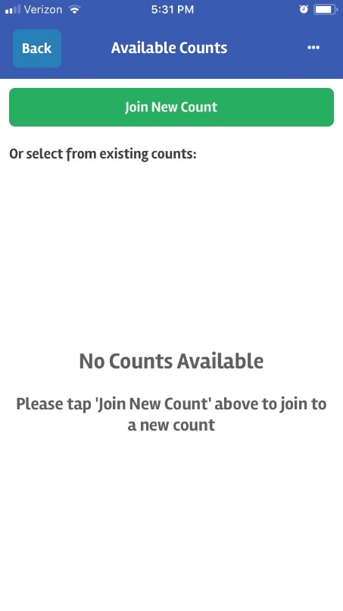

**1**



TX2021

TX2019



**4**

**6**

**5**

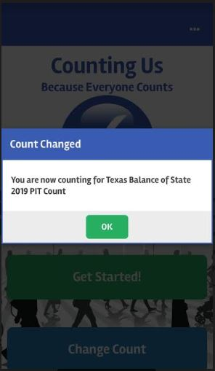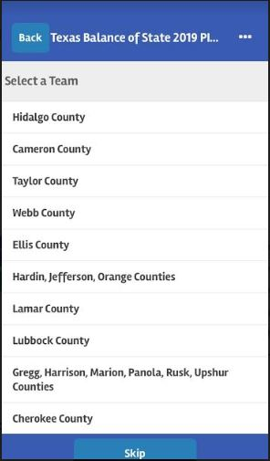

You are now counting for Texas Balance of State 2021 PIT Count