Counting Us App Cheat Sheet

How to begin Counting:
- Register for the Count on the Registration Portal: https://txbos.pointintime.info/
- Download the Counting Us app
- Create log-in information
- Enter in set-up key TXBoS2024
- On the Select a Team screen, select the team you are volunteering for. ALL VOLUNTEERS HAVE A TEAM
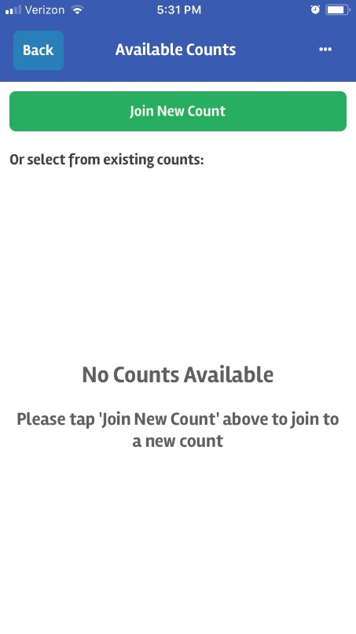
3
2
1

TXBoS2024
TX2019

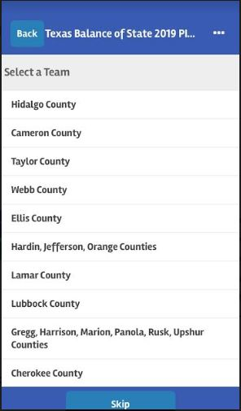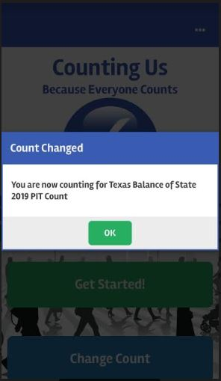
6
5
4

You are now counting for Texas Balance of State 2024 PIT Count

